ISCG5421 Programming Principles and Practice

Zhiyu Lei (Zavier Ray)

Yifan Liu (Lux)

Yao Sun (Sam)

Andrey Chaltsev

Library Program

Documentation

Contents

Marking Schedule 2

Entity class diagram/workload breakdown 4

Printouts of screens showing data 6

Test plan checkpoints with screen shots of the results 8

Meeting minutes/discussion 66

# Marking Schedule

|  |  |  |  |  |  |  |
| --- | --- | --- | --- | --- | --- | --- |
| Assignment Marking Schedule  (This assignment contributes 40% to your final grade) | | | | | | |
| Team members (name): | Zhiyu Lei | Yifan Liu | | Yao Sun | | **Andrey Chaltsev** |
|  | | | | | | |
|  | | | **Marks Allocated** | | **Your mark** | |
| **Phase 1: Design and Plan**  We will look at the completeness, quality and correctness (use of abstraction, decomposition and encapsulation) of your:   * UML Design Diagram (5 marks)   + - Identification of your real-world objects (classes) and their characteristics     - Interaction (relationship) between your real-world objects     - Reusable classes     - Appropriate data types and methods * Workflow plan (5 marks)   + - Reasonable and feasible plan     - Rational division of workload * Extra things (5 marks)   + - Other design methodologies involved.     - System scale expanded | | | **10 + 5** | |  | |
| **Phase 2: Implementation**   * GUI (15 marks)   + - Range of controls     - Appropriate controls     - Presentation of controls     - Functionality of controls * Program (15 marks)   + - Binary File handling     - Input and Output constructs     - Methods     - Use of constants/ static variables     - No unnecessary repetition of code     - Program performance efficiency     - Consistent and appropriate user interactions (e.g. prompts and error messages) * Operation (15 marks)   + - Program runs according to specification     - No errors * Extra things (10 marks):   + - Using of Databases     - More functionalities added | | | **45 + 10** | |  | |
| **Phase 3: Testing**   * Testing plan (15 marks)   Actual result indicated (Screen shots provided)  No duplicate tests  Exhaustive test cases | | | **15** | |  | |
| **Phase 4: Demonstration**   * Presentation (10 marks) * Q&A (5 marks) | | | **15** | |  | |
| **Novelty, Creativity (Bonus Marks)** | | | **5** | |  | |

|  |  |  |
| --- | --- | --- |
| **COMMENTS** | | |
|  | | |
| **NOTE:** If the programdoes not compile**, a mark of 0 will be awarded for the assignment** | | |
| **Assignment Total** | **100** |  |

# Entity class diagram/workload breakdown



# Printouts of screens showing data

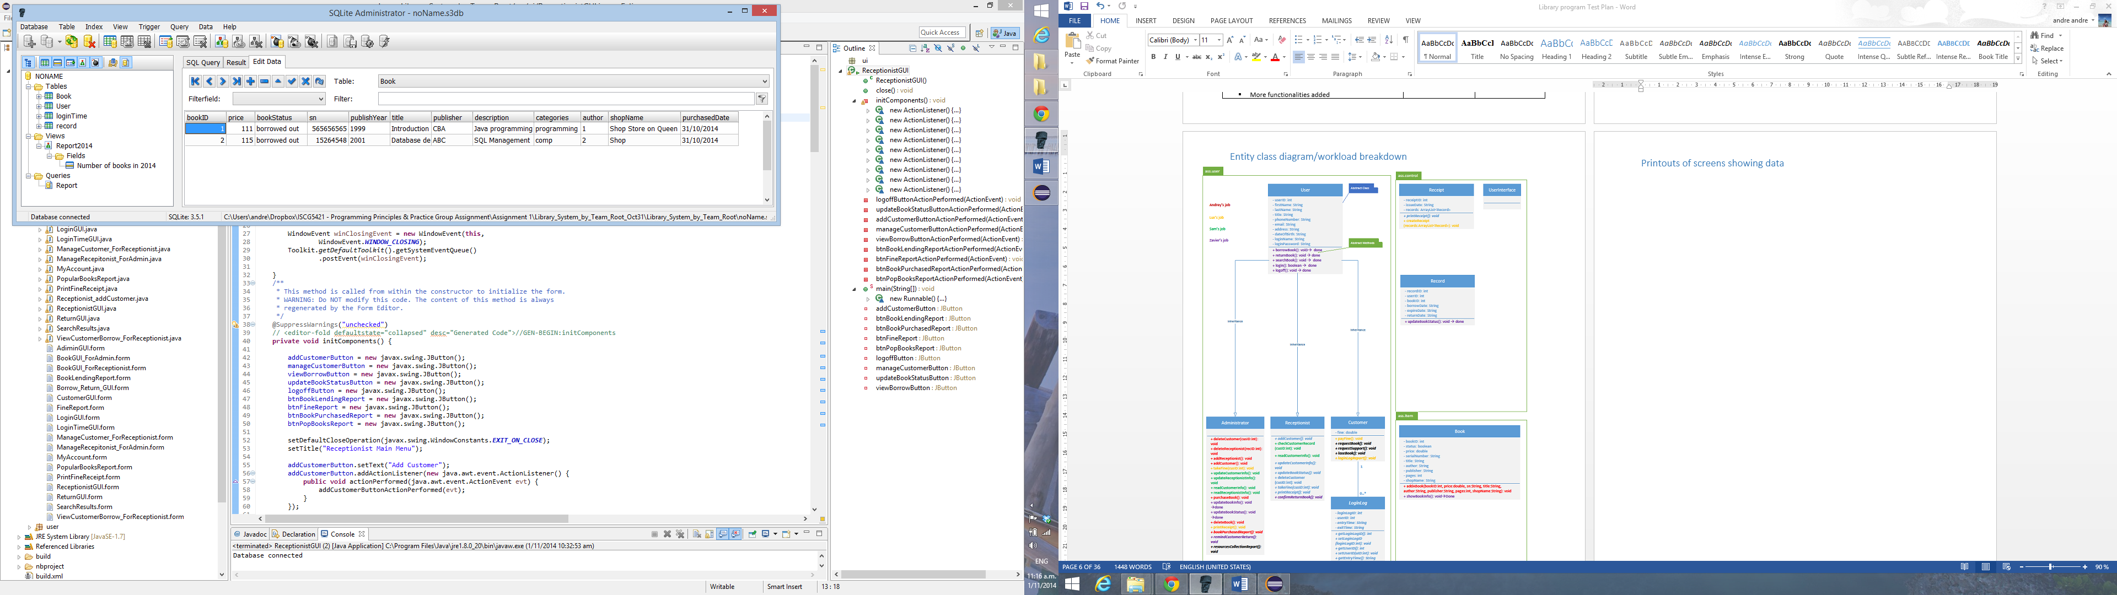

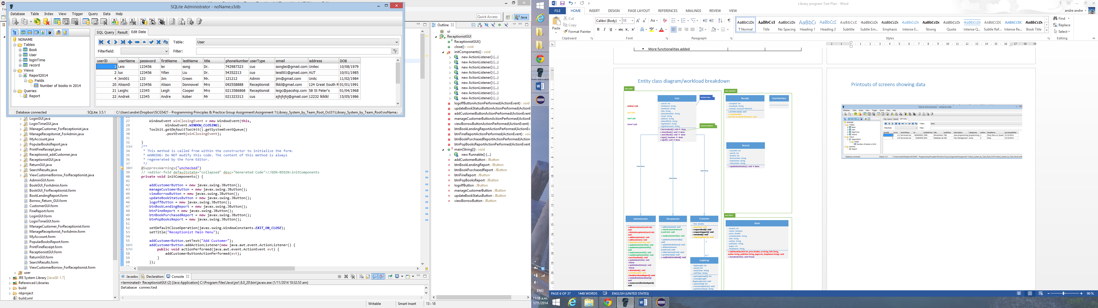

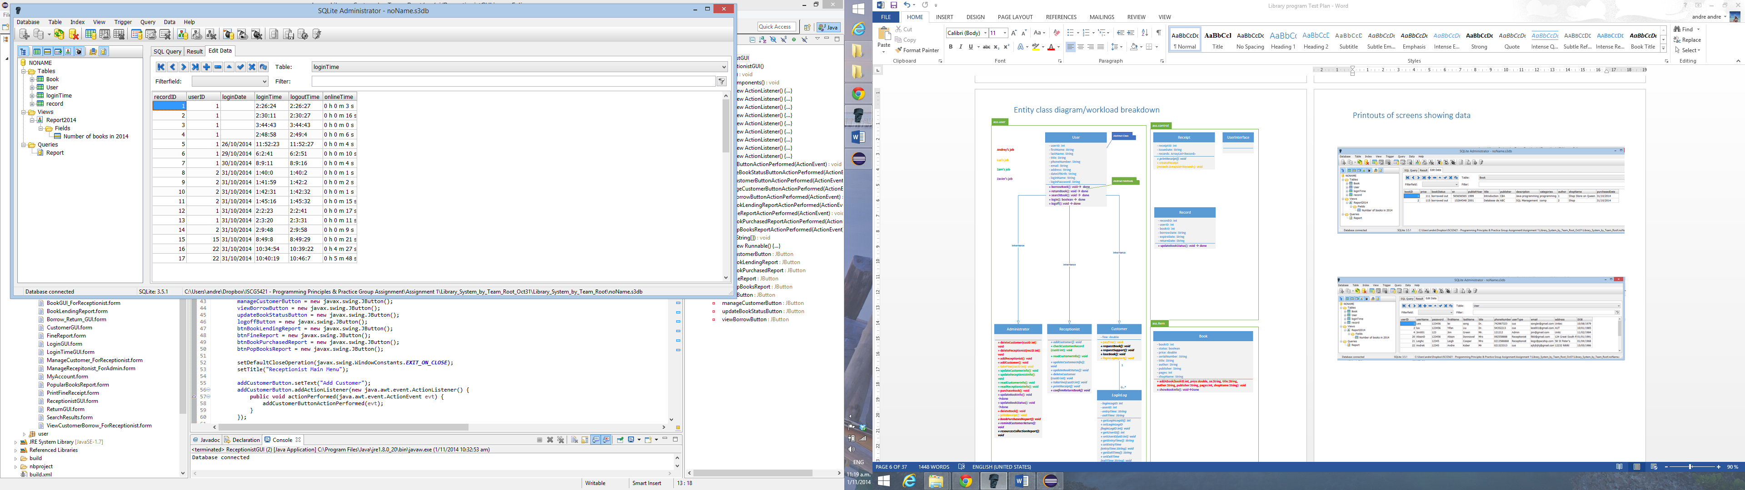

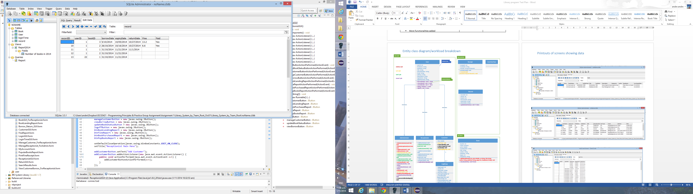

# Test plan checkpoints with screen shots of the results

TEST PLAN FOR LIBRARY PROGRAM

|  |  |  |  |
| --- | --- | --- | --- |
| **CHECKPOINTS** | | |  |
|  | Expected | **Actual** | **Fault No** |
| 1) Does the login window displayed at the programs startup? | Y | **Y** |  |
| 2) Does it have different user groups log in options? | Y | **Y** |  |
| 3) Does a user name / password gets validated for each type of user? | Y | **Y** |  |
| 4) Does administrator’s main menu page gets displayed after correct administrator’s user name and password are entered? | Y | **Y** |  |
| 5) Does a purchase book window correctly displayed after Purchase Book button clicked? | Y | **Y** |  |
| 6) Does a new book’s data input gets validated? | Y | **Y** |  |
| 7) Does a book gets correctly added after all information entered and Add book button clicked? | Y | **Y** |  |
| 8) Does a manage books window gets correctly displayed after manage books button clicked? | Y | **Y** |  |
| 9) Does a search function works correctly? | Y | **Y** |  |
| 10) Does update function work updates fields correctly? | Y | **Y** |  |
| 11) Does clear function work correctly? | Y | **Y** |  |
| 12) Does a delete function work correctly? | Y | **Y** |  |
| 13) Does Add receptionist window get correctly displayed after Add receptionist button is clicked? | Y | **Y** |  |
| 14) Does a validation for phone number / email address and date of birth work correctly? | Y | **Y** |  |
| 15) Does add receptionist function work correctly? | Y | **Y** |  |
| 16) Does manage receptionist window get properly displayed after manage receptionist button clicked? | Y | **Y** |  |
| 17) Does a validation for a phone number / email address work correctly? | Y | **Y** |  |
| 18) Does update/delete receptionist functions work correctly? | Y | **Y** |  |
| 19) Does book lending report window opens and displays correct information? | Y | **Y** |  |
| 20) Does fine report opens and displays correct information? | Y | **Y** |  |
| 21) Does books purchased report window open and display correct information? | Y | **Y** |  |
| 22) Does popular books report window open and display correct information? | Y | **Y** |  |
| 23) Does a receptionist’s main menu get displayed correctly? | Y | **Y** |  |
| 24) Does add customer window opens / functions correctly? | Y | **Y** |  |
| 25) Does manage customer window opens correctly? | Y | **Y** |  |
| 26) Does email/phone number fields get validated? | Y | **Y** |  |
| 27) Does update function work updates fields correctly? | Y | **Y** |  |
| 28) Does clear function works correctly? | Y | **Y** |  |
| 29) Does a delete function work correctly? | Y | **Y** |  |
| 30) Does view customer borrow opens and work correctly? | Y | **Y** |  |
| 31) Does manage books window get correctly displayed and functions correctly? | Y | **Y** |  |
| 32) Does borrow lending report window opens and functions correctly? | Y | **Y** |  |
| 33) Does fine report opens and displays correct information? | Y | **Y** |  |
| 34) Does books purchased report window open and display correct information? | Y | **Y** |  |
| 35) Does popular books report window opens and functions correctly? | Y | **Y** |  |
| 36) Does customer’s main menu get displayed correctly? | Y | **y** |  |
| 37) Does a search function work correctly? | Y | **Y** |  |
| 38) Does my account window open and displays correct information? | Y | **Y** |  |

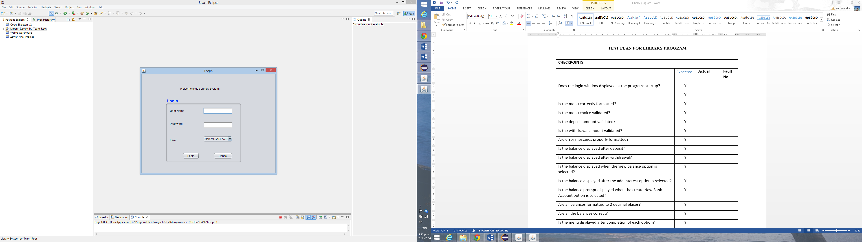

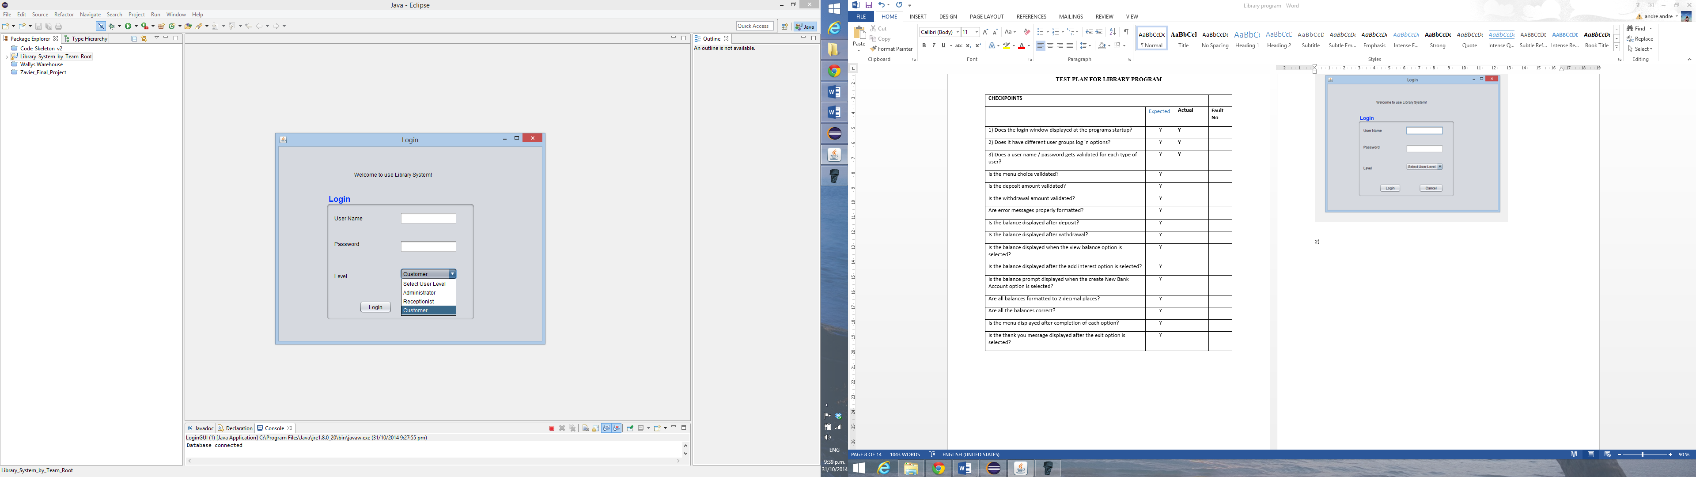

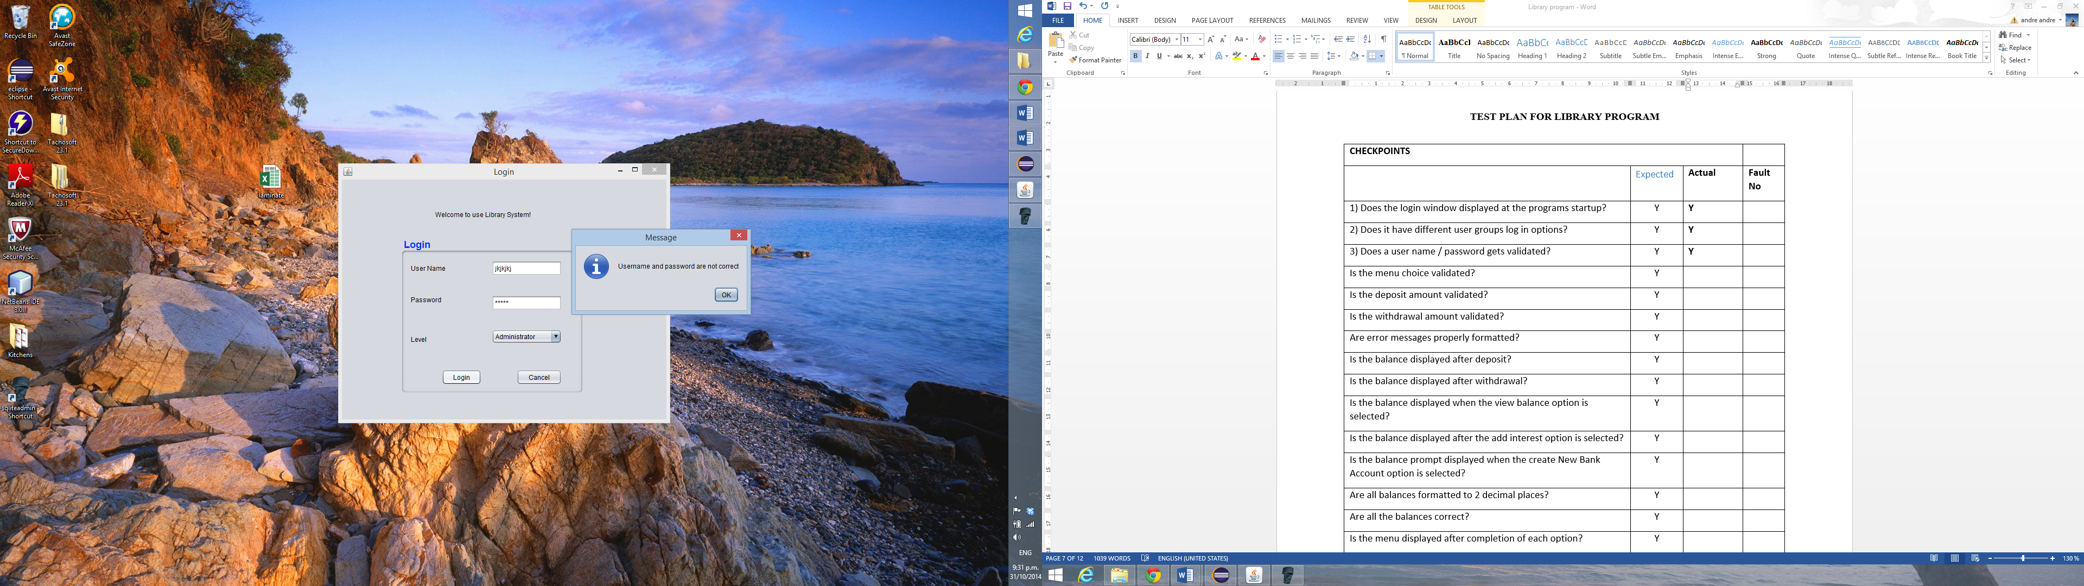

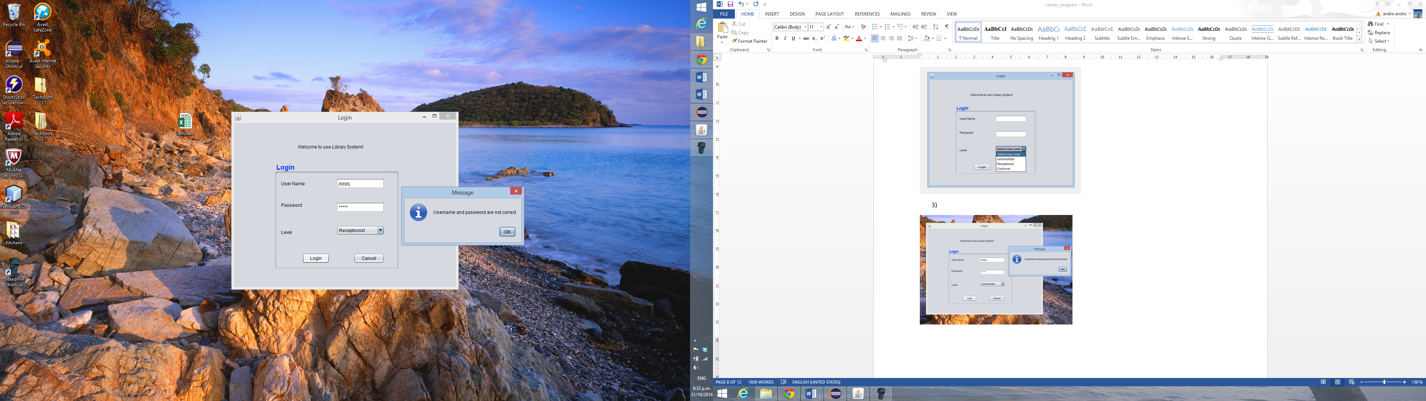

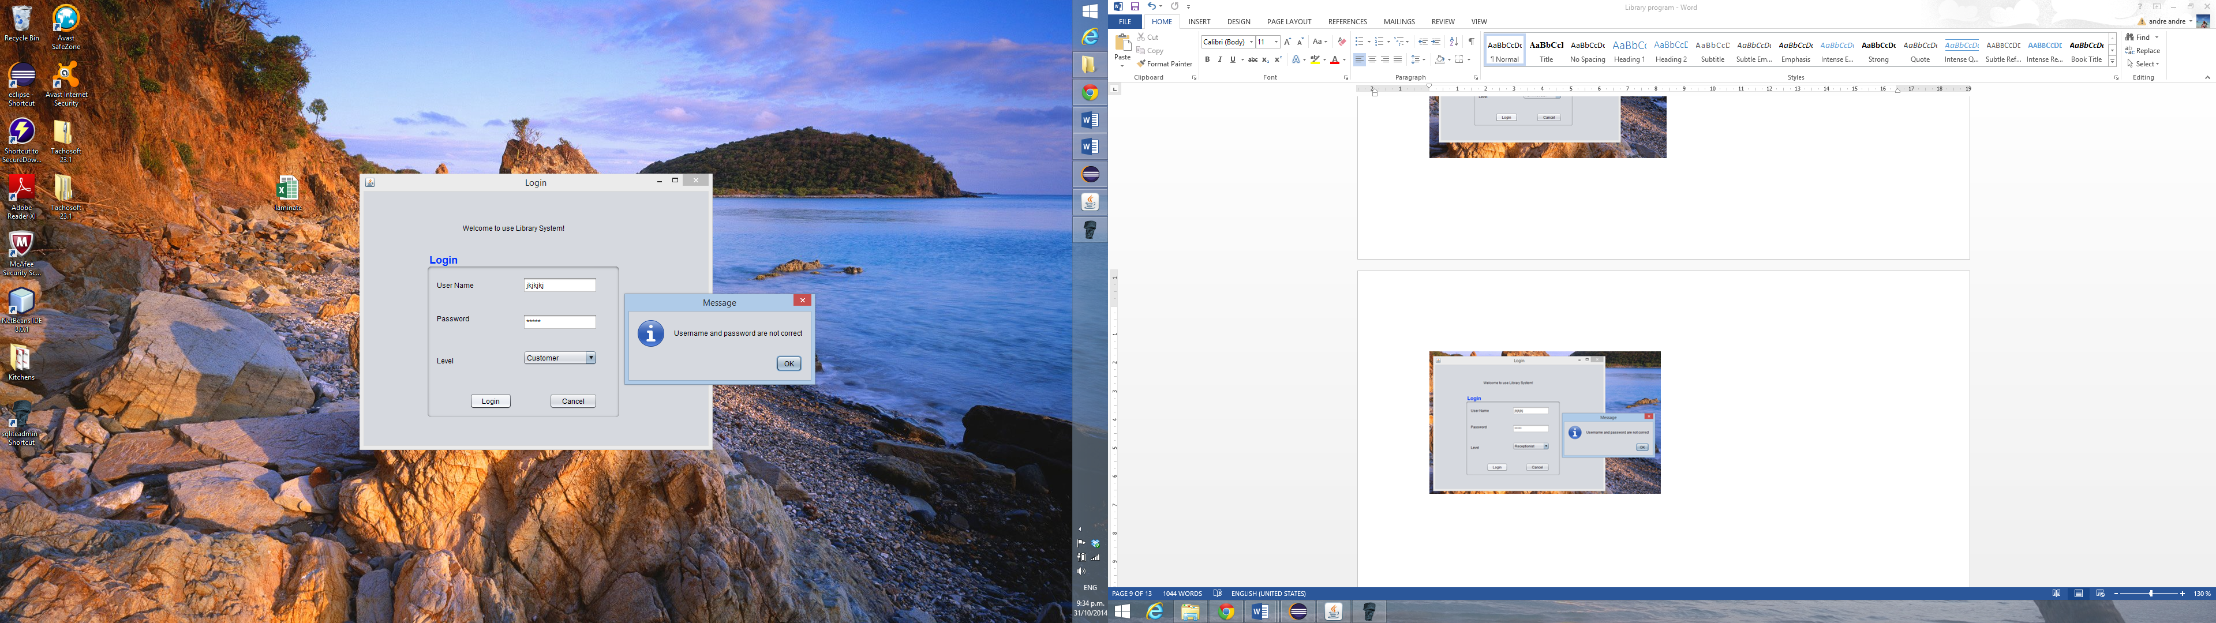

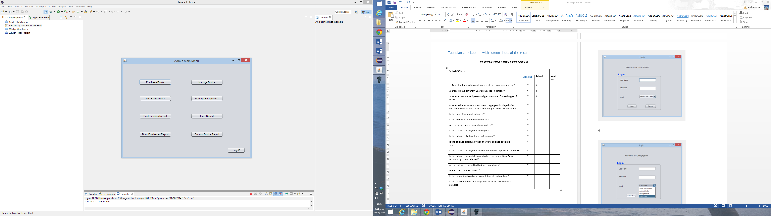

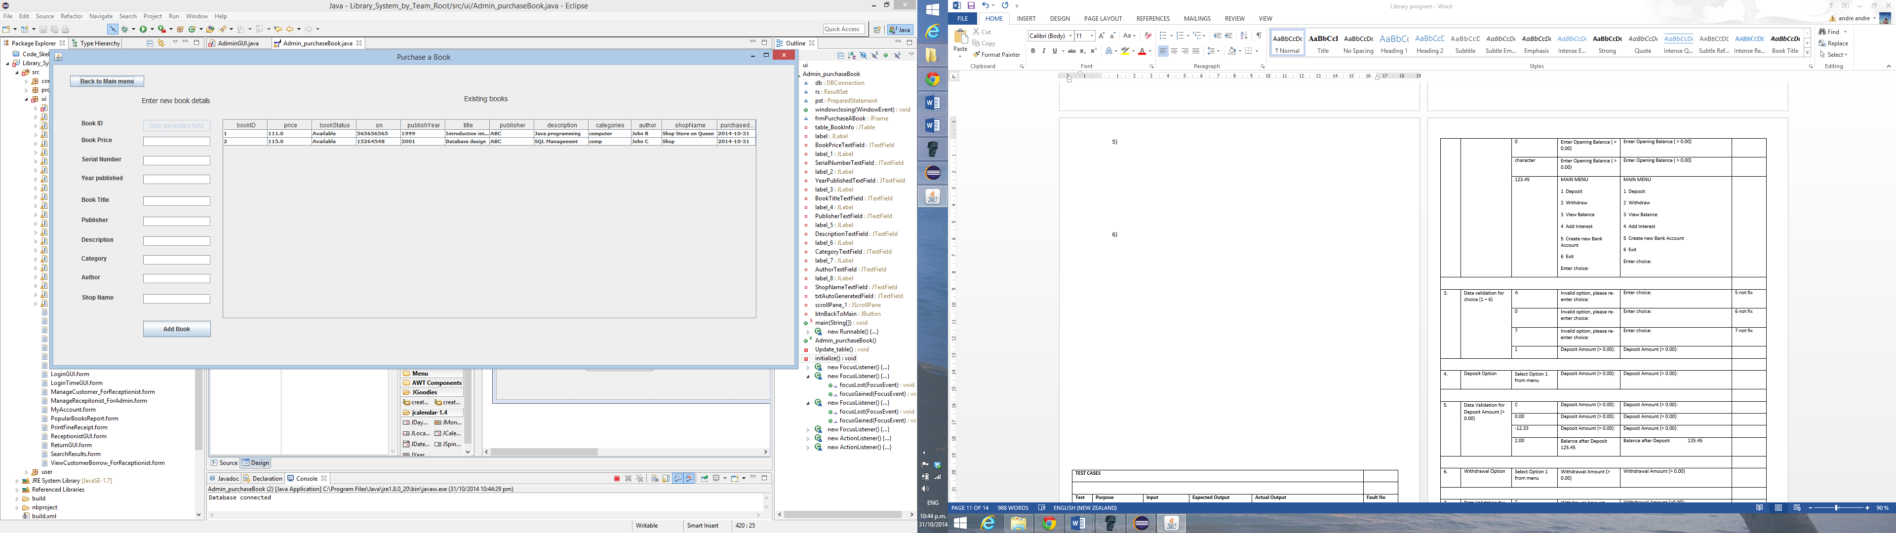

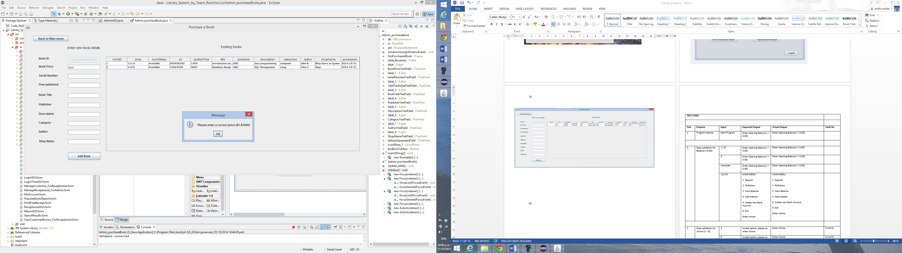

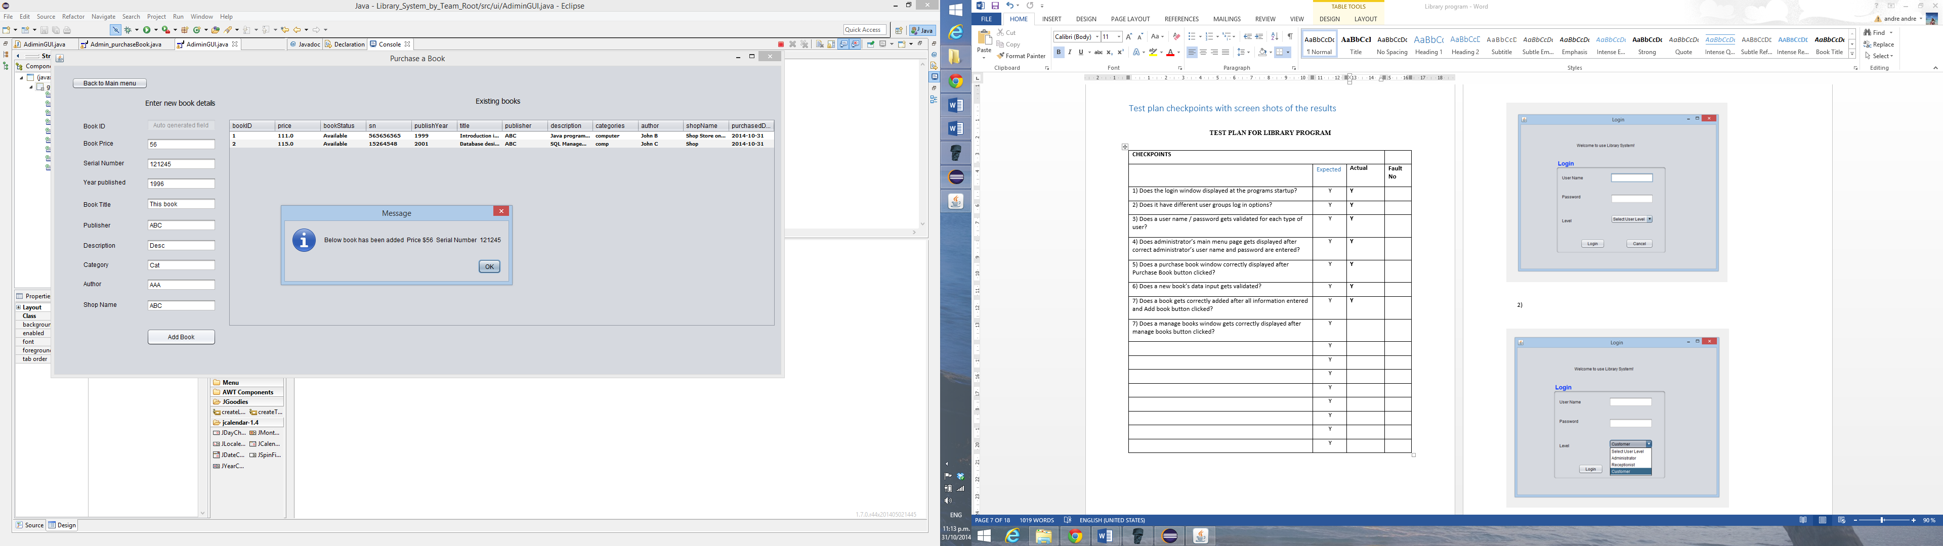

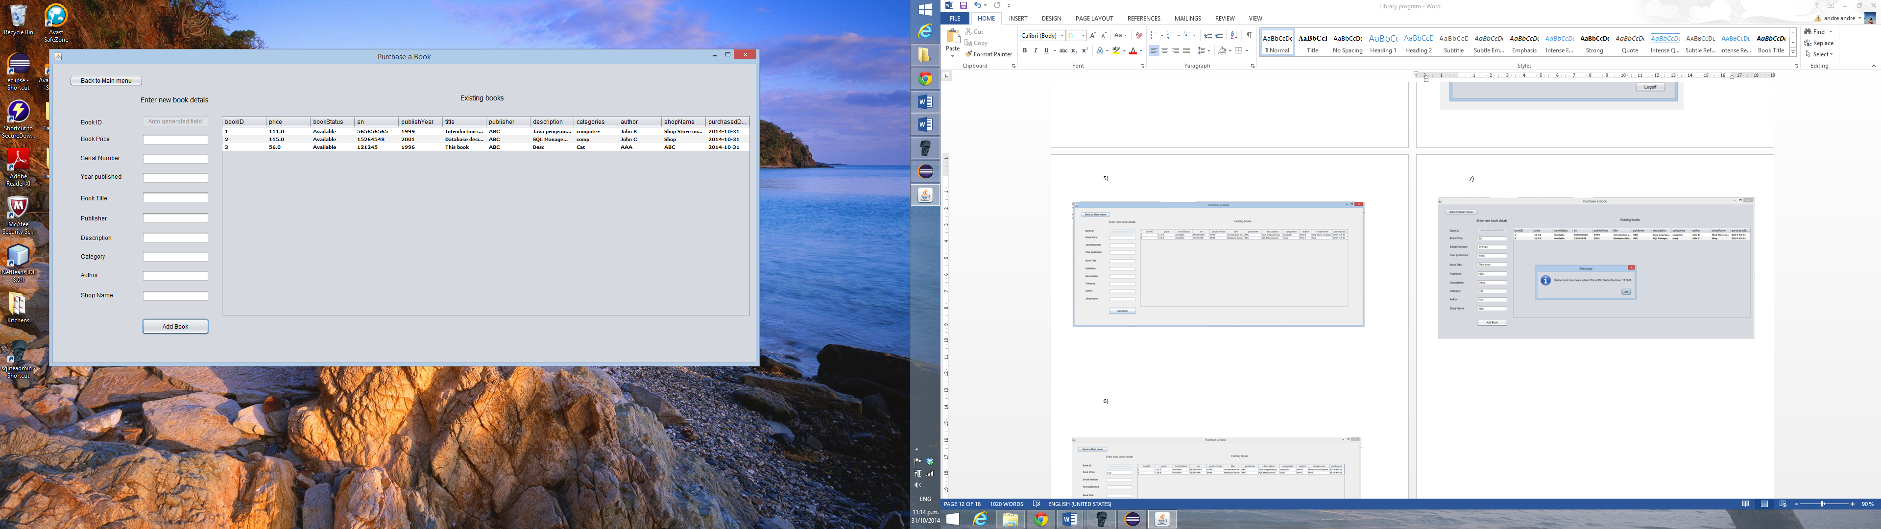

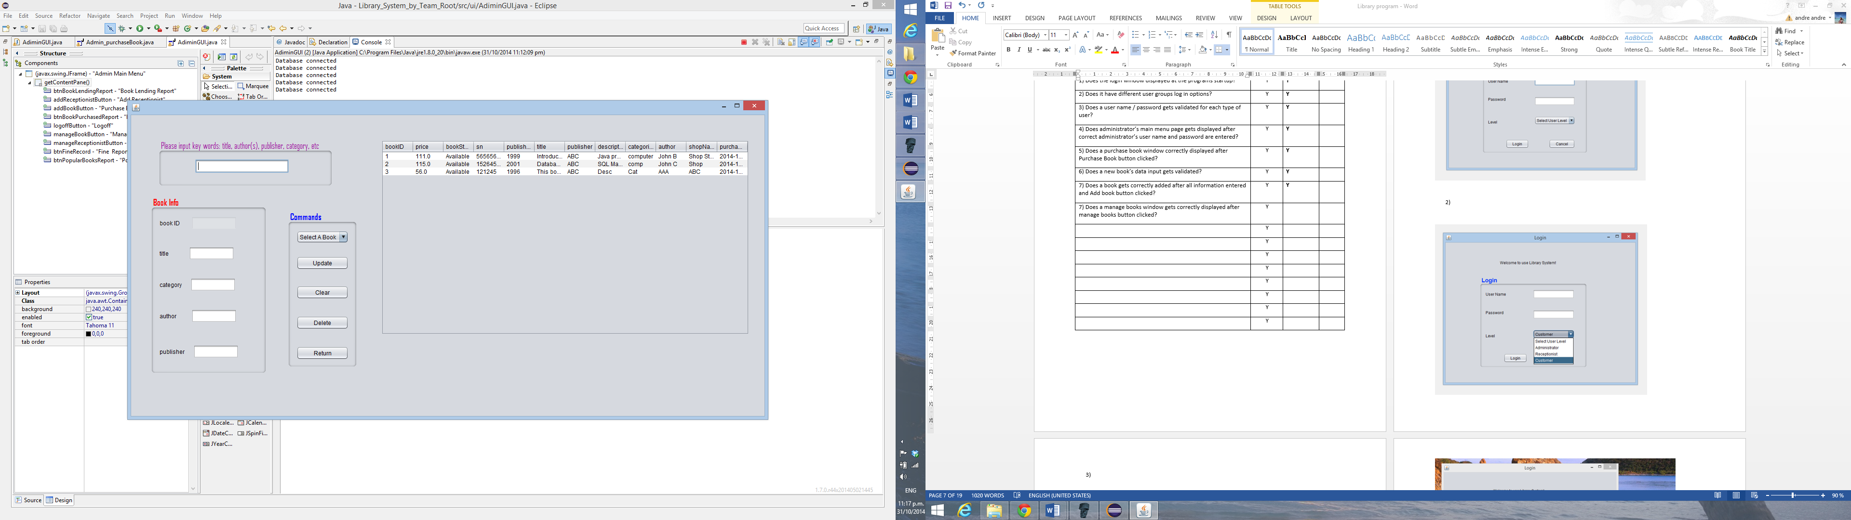

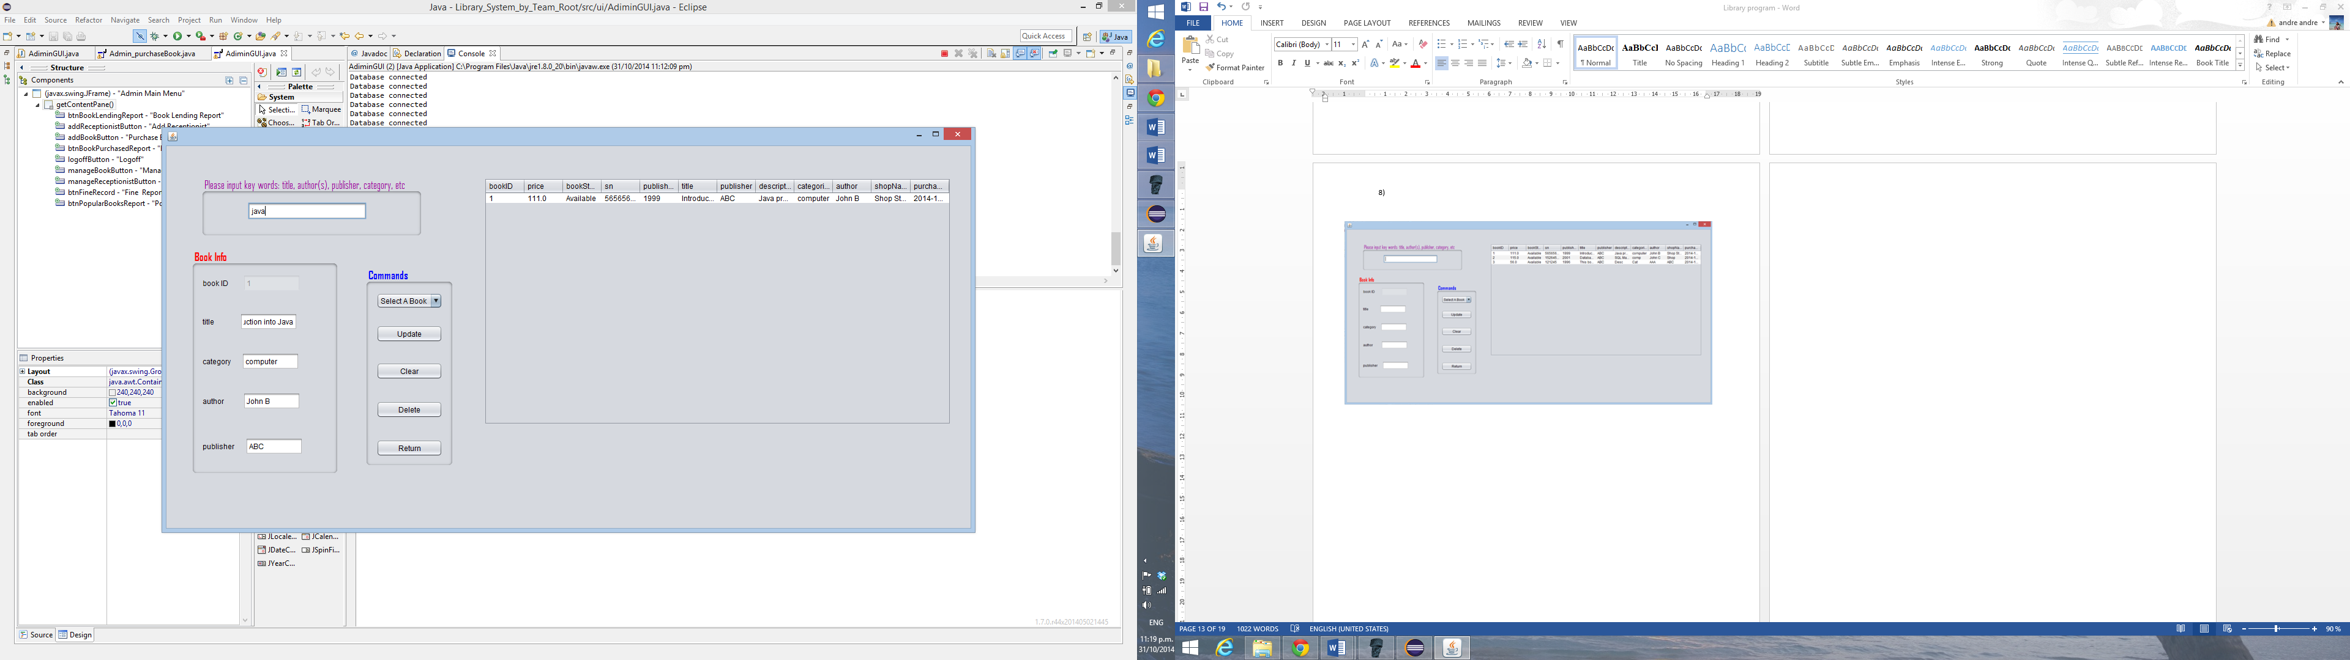

10)

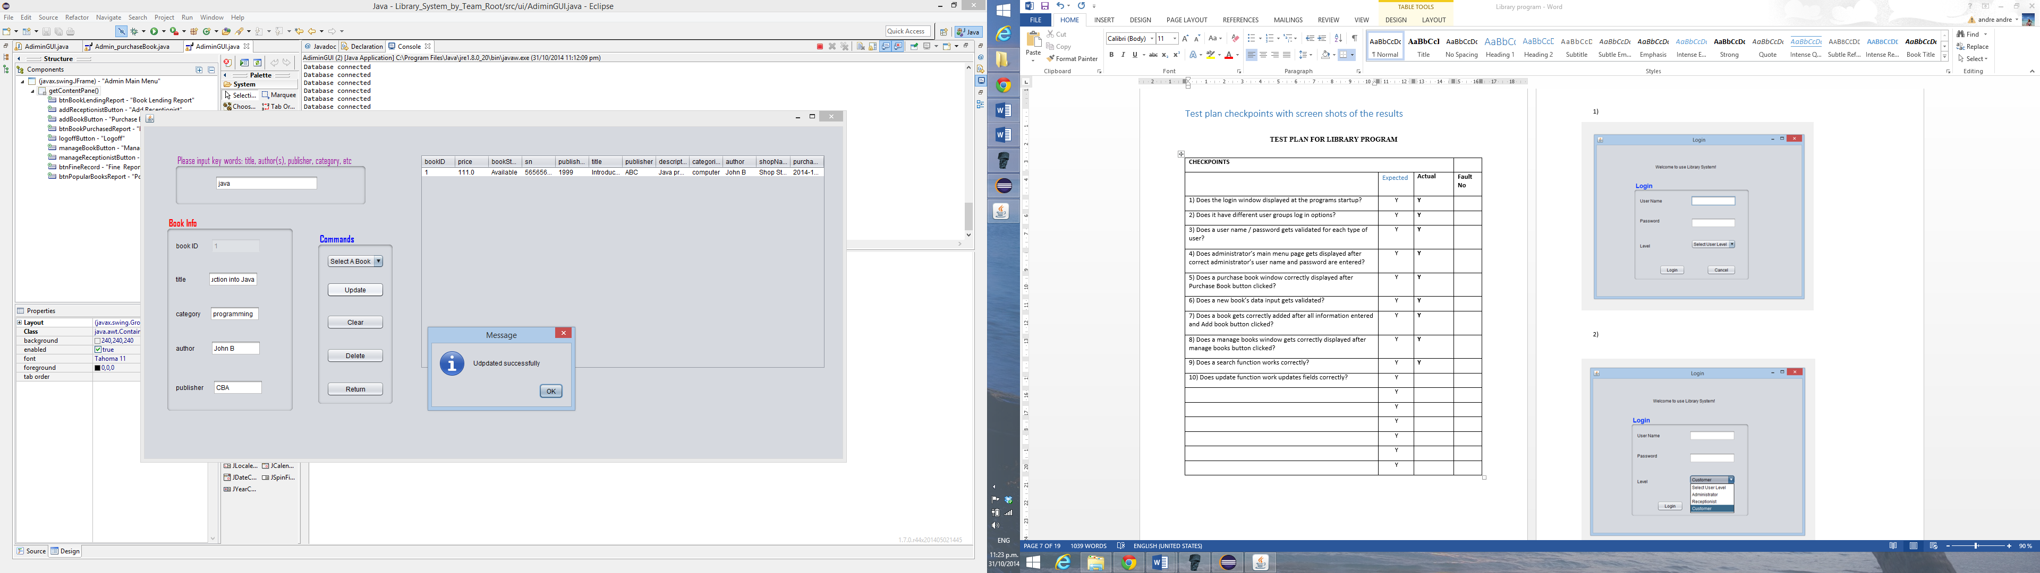

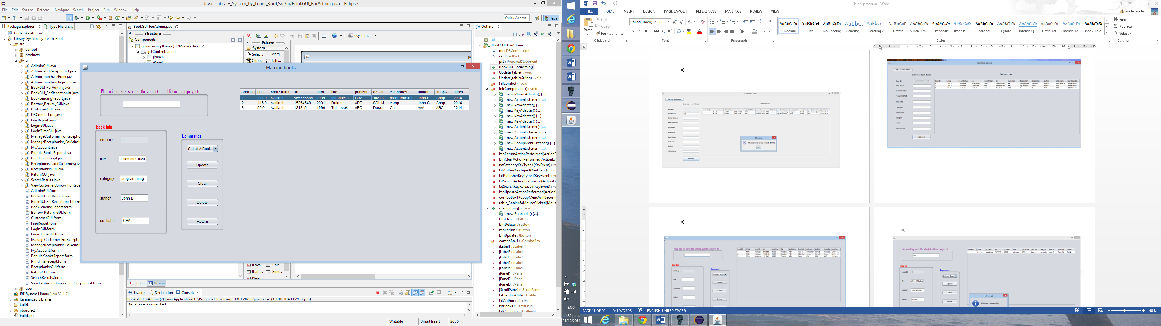

11)

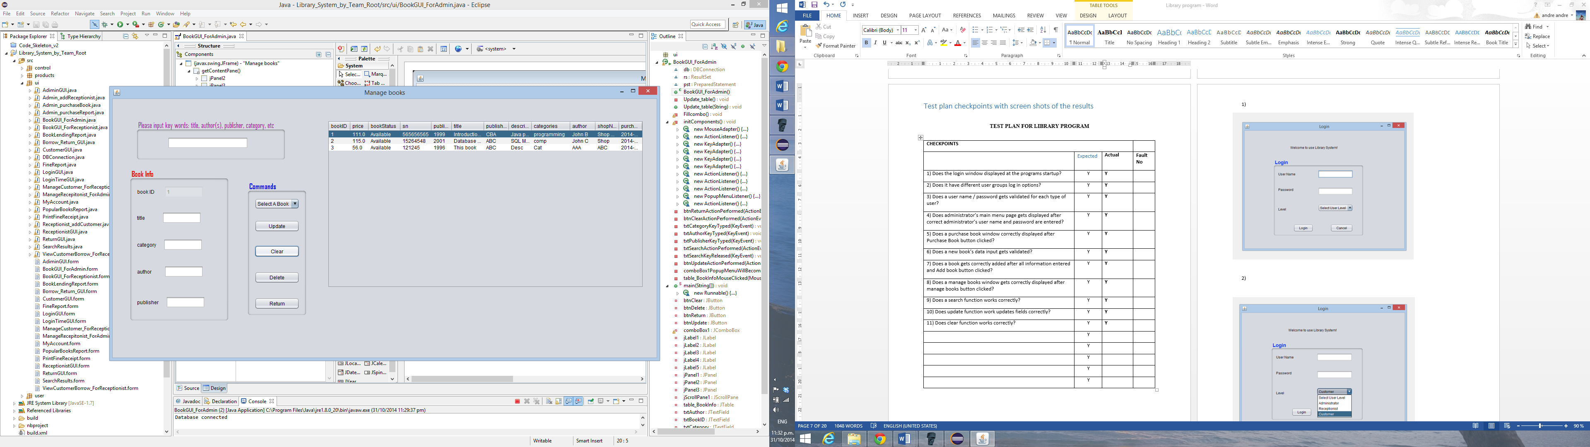

12)

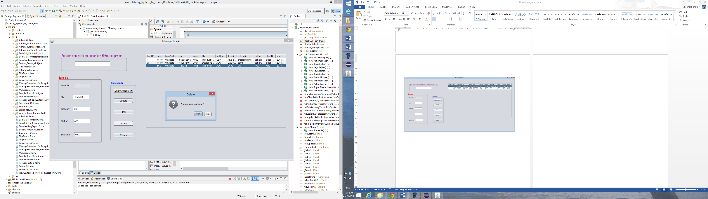

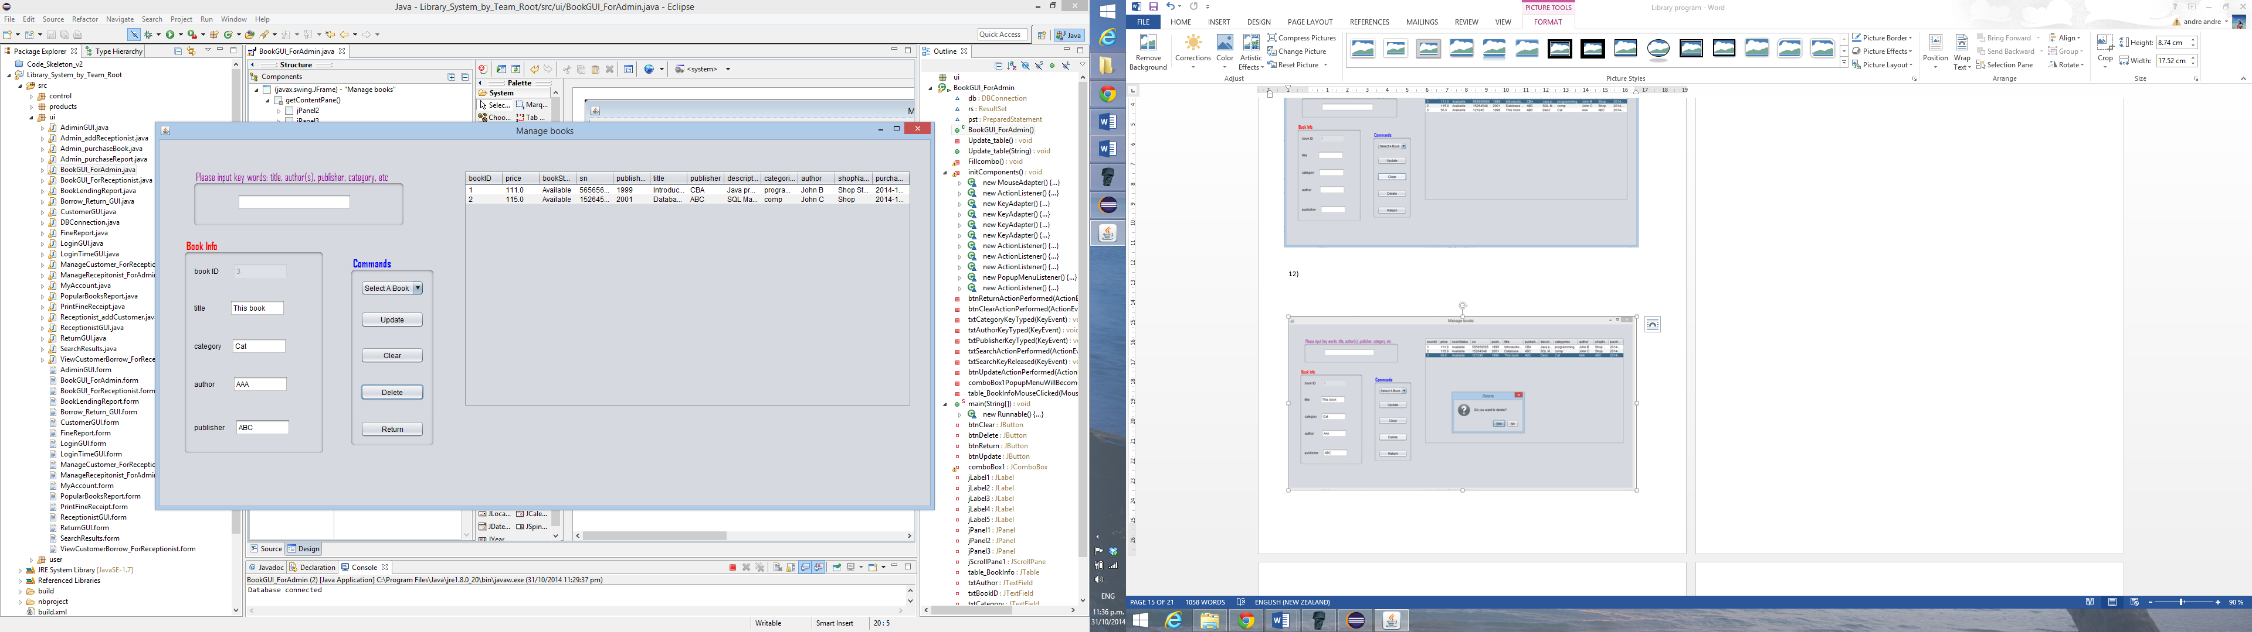

13)

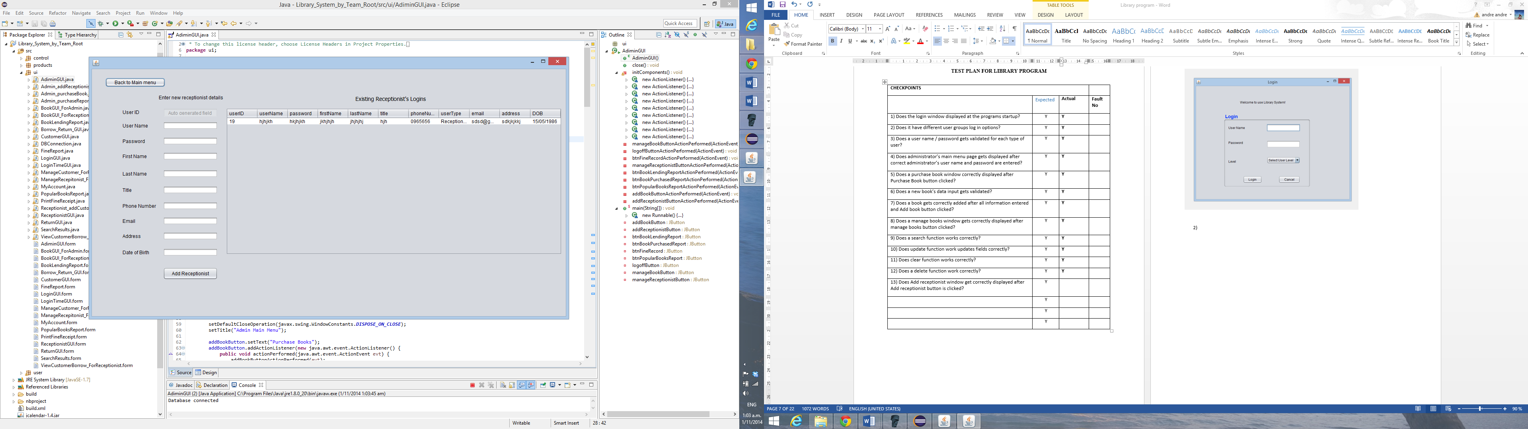

14)

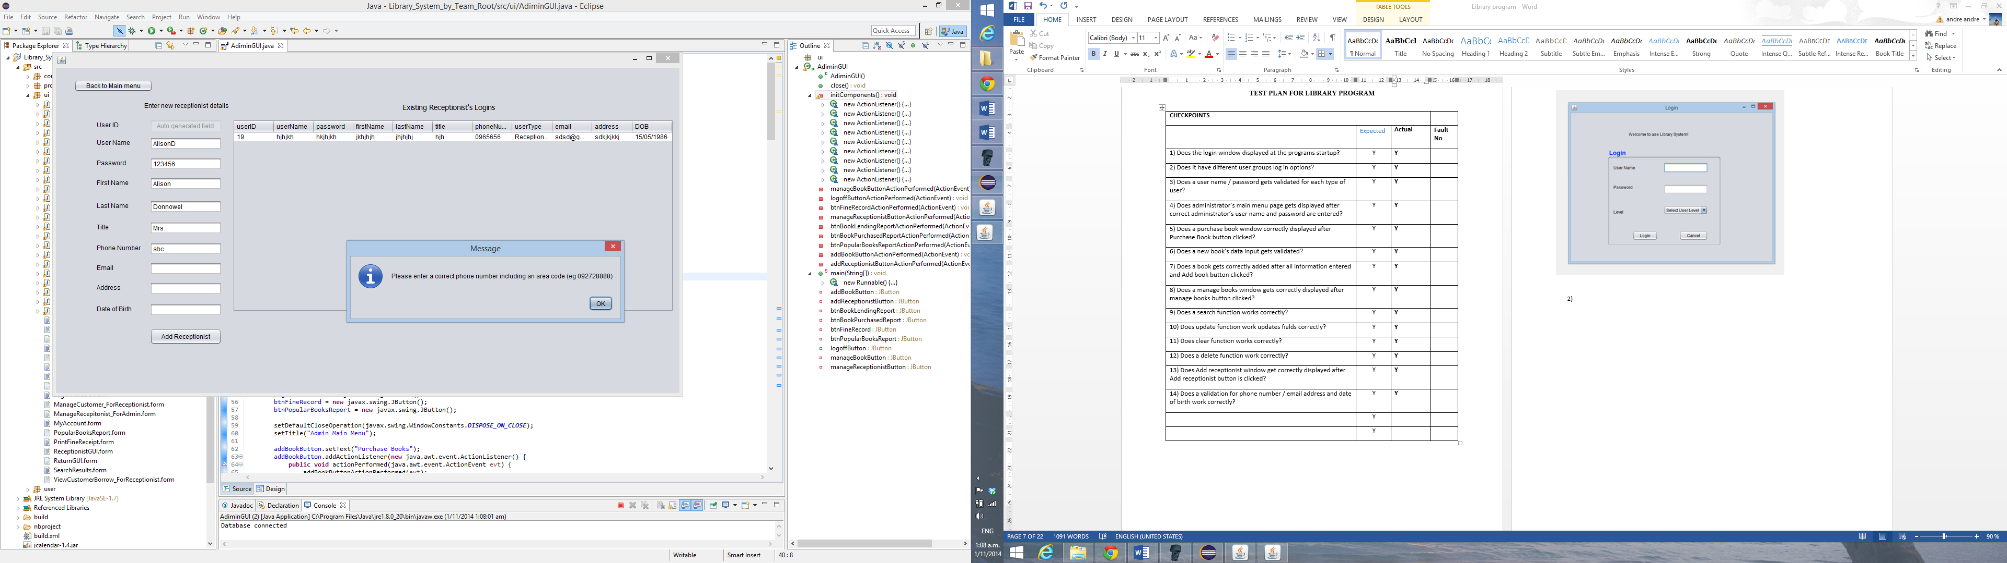

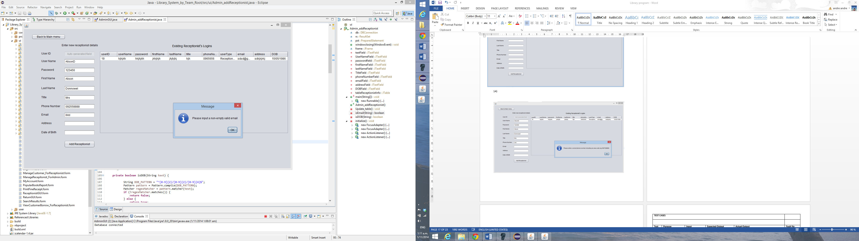

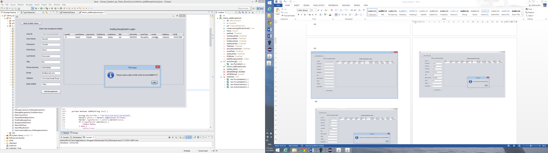

15)

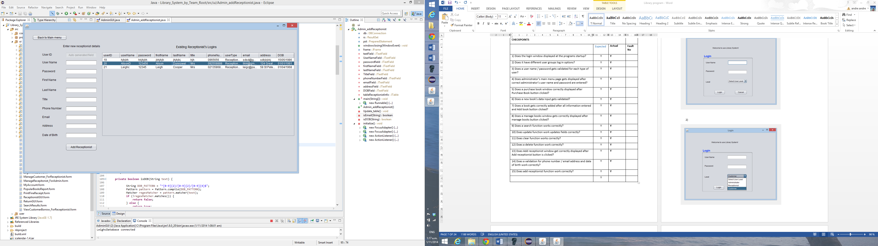

16)

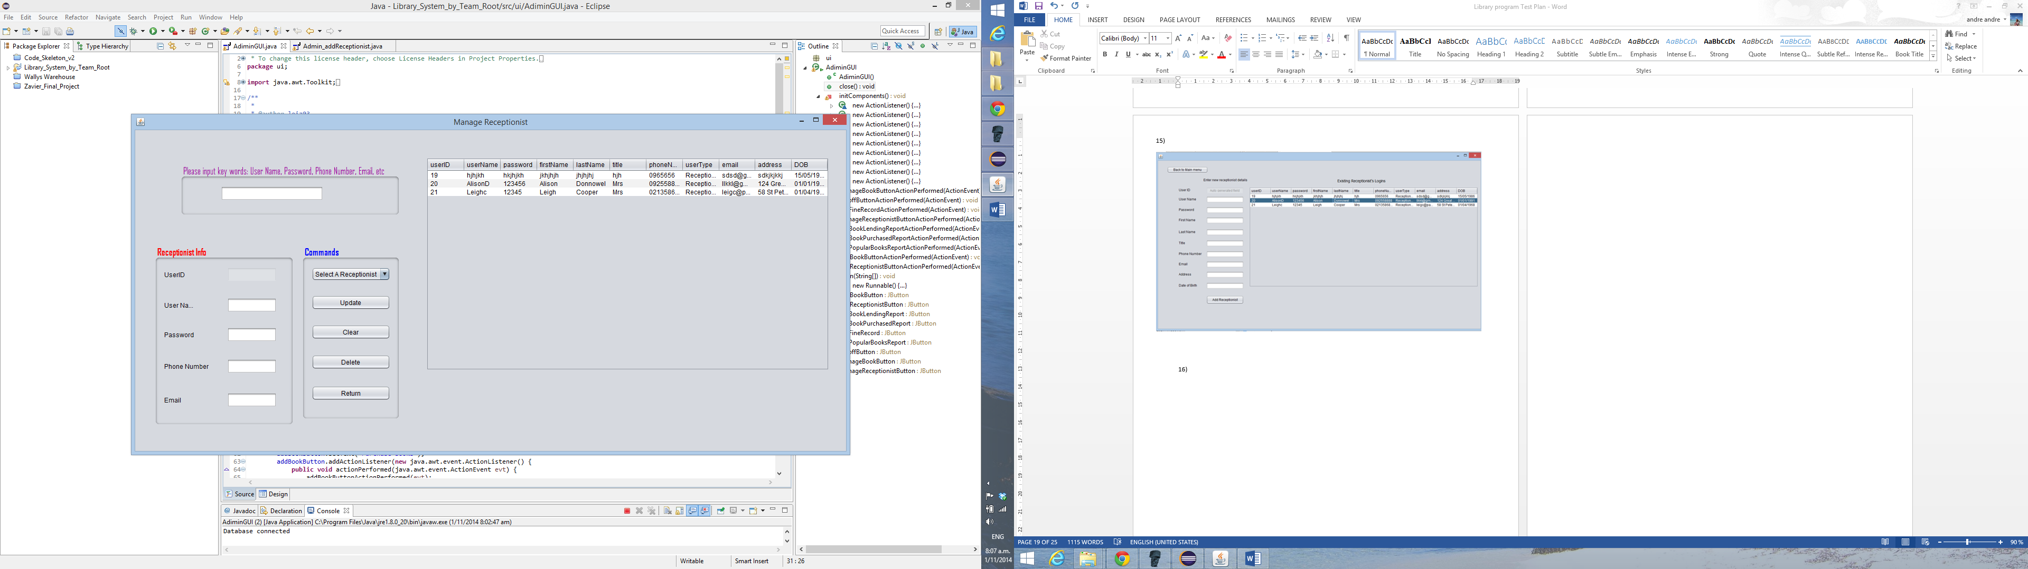

17)

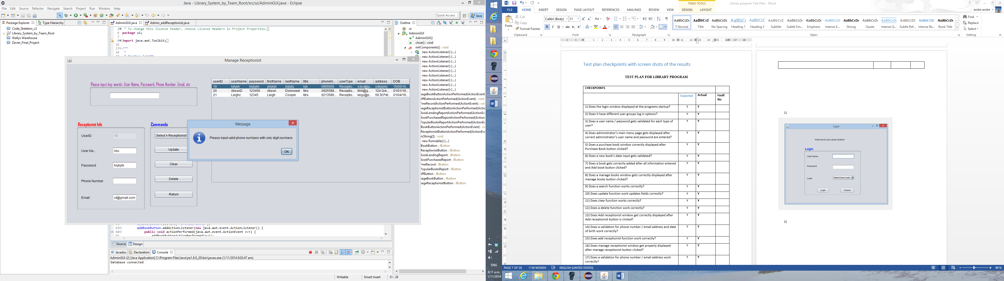

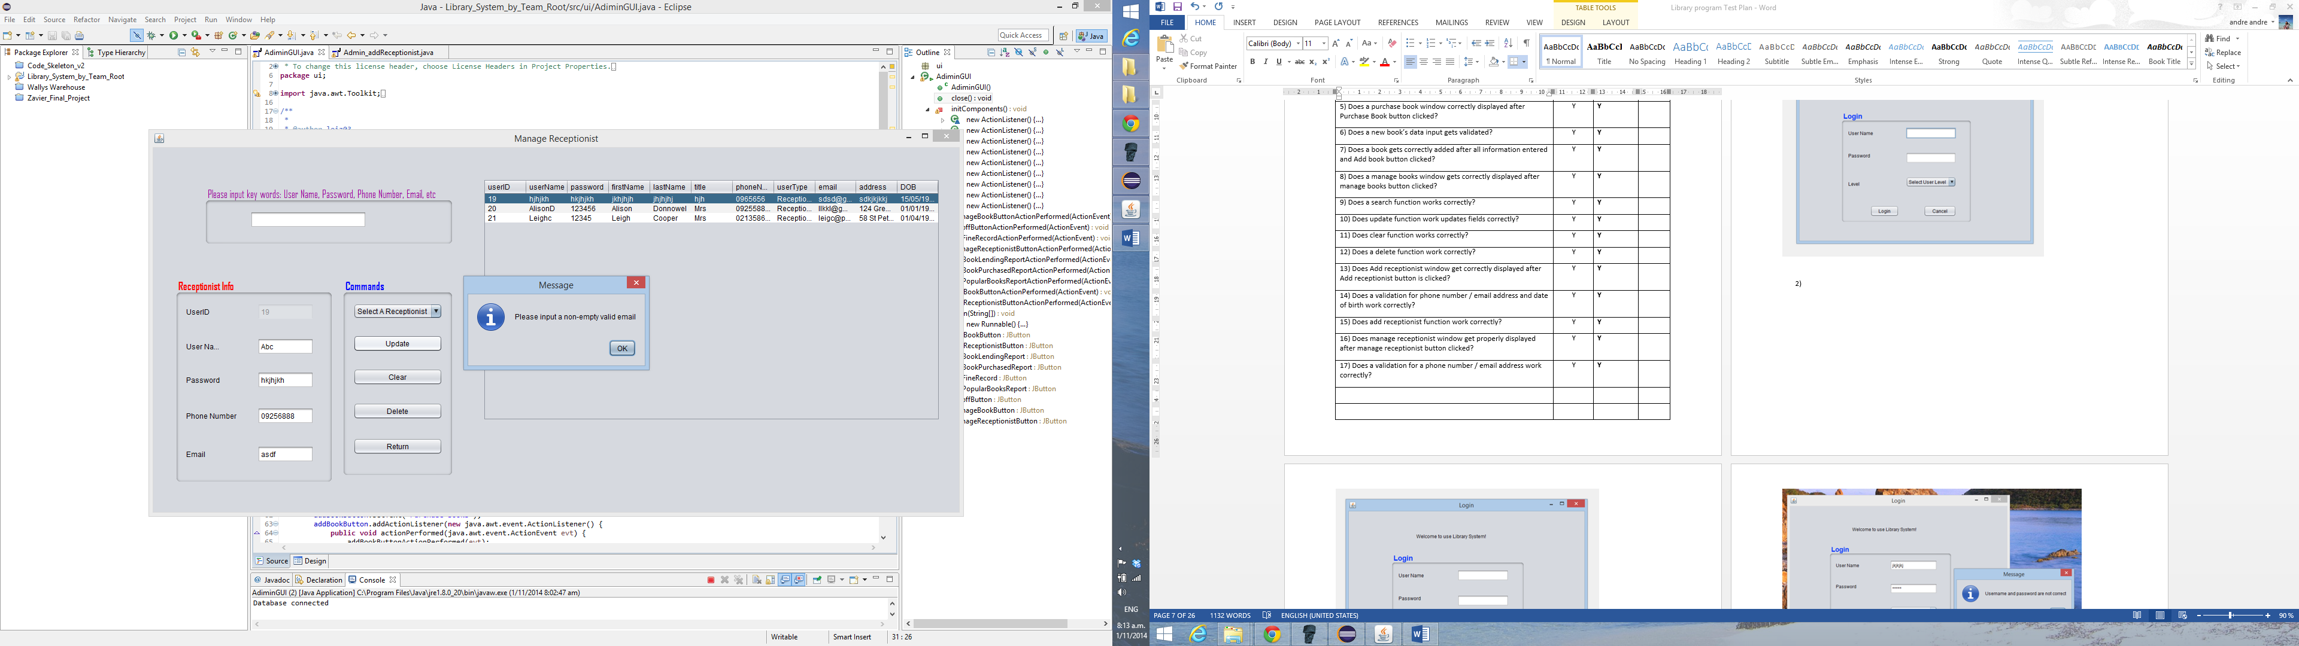

18)



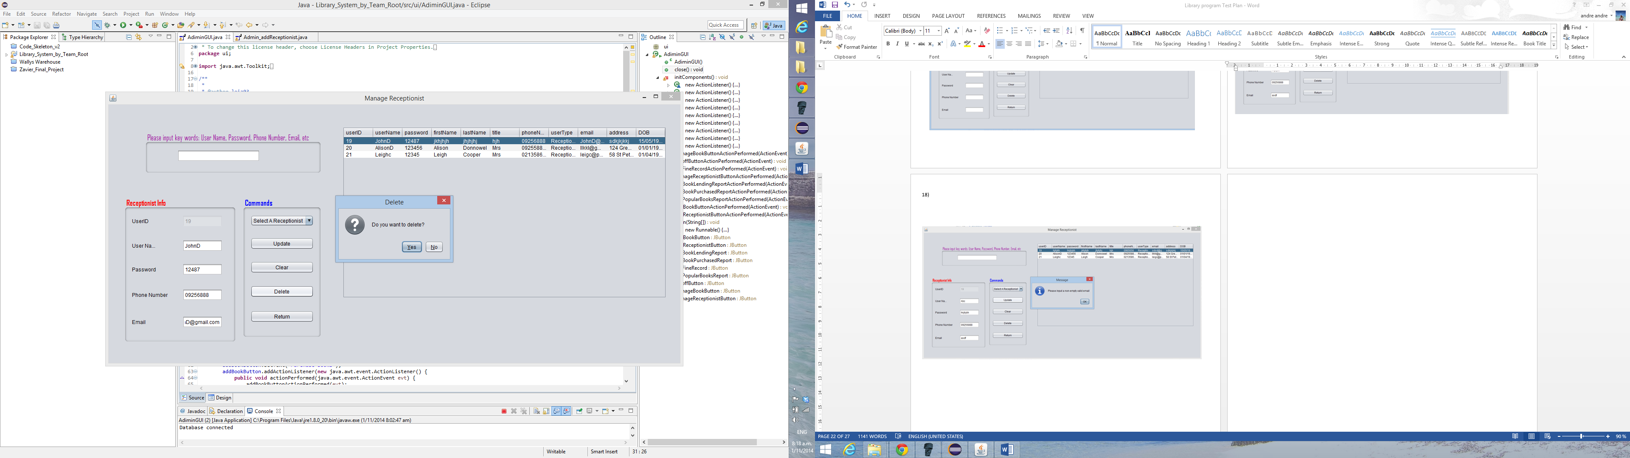

19)

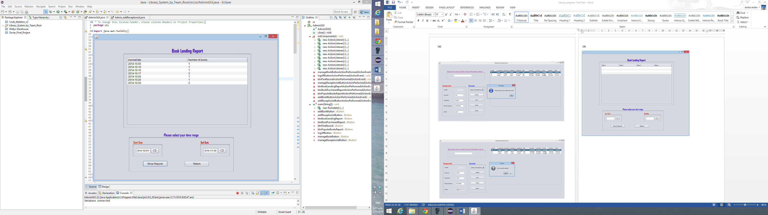

20)

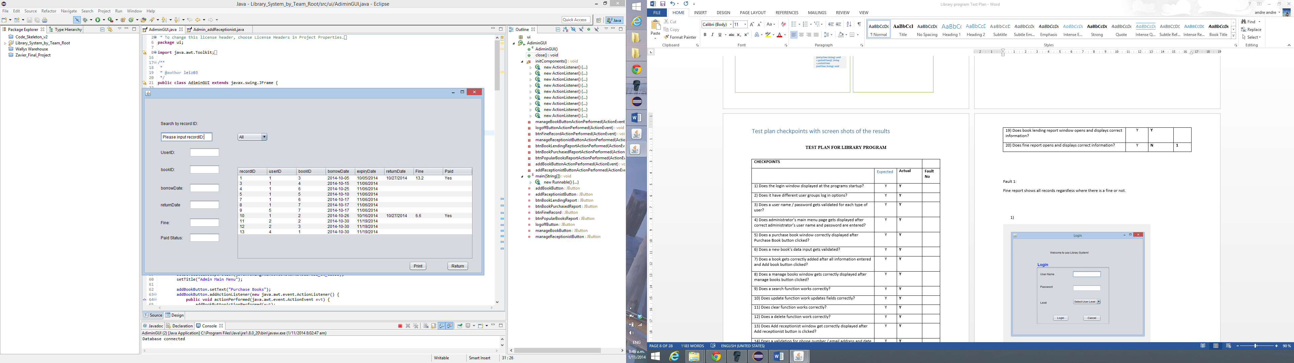

21)

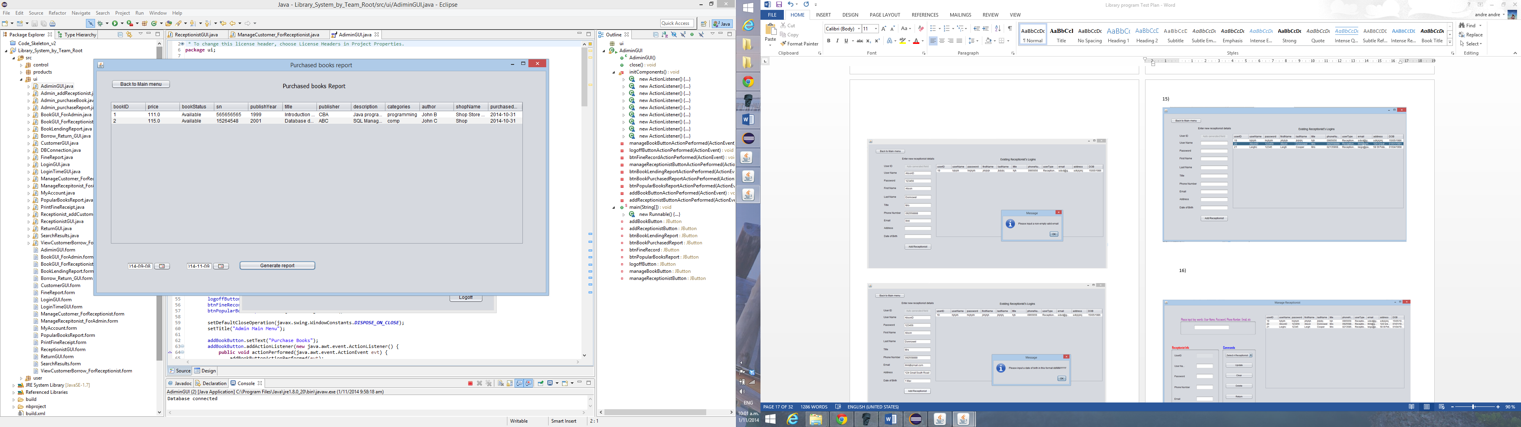 22)

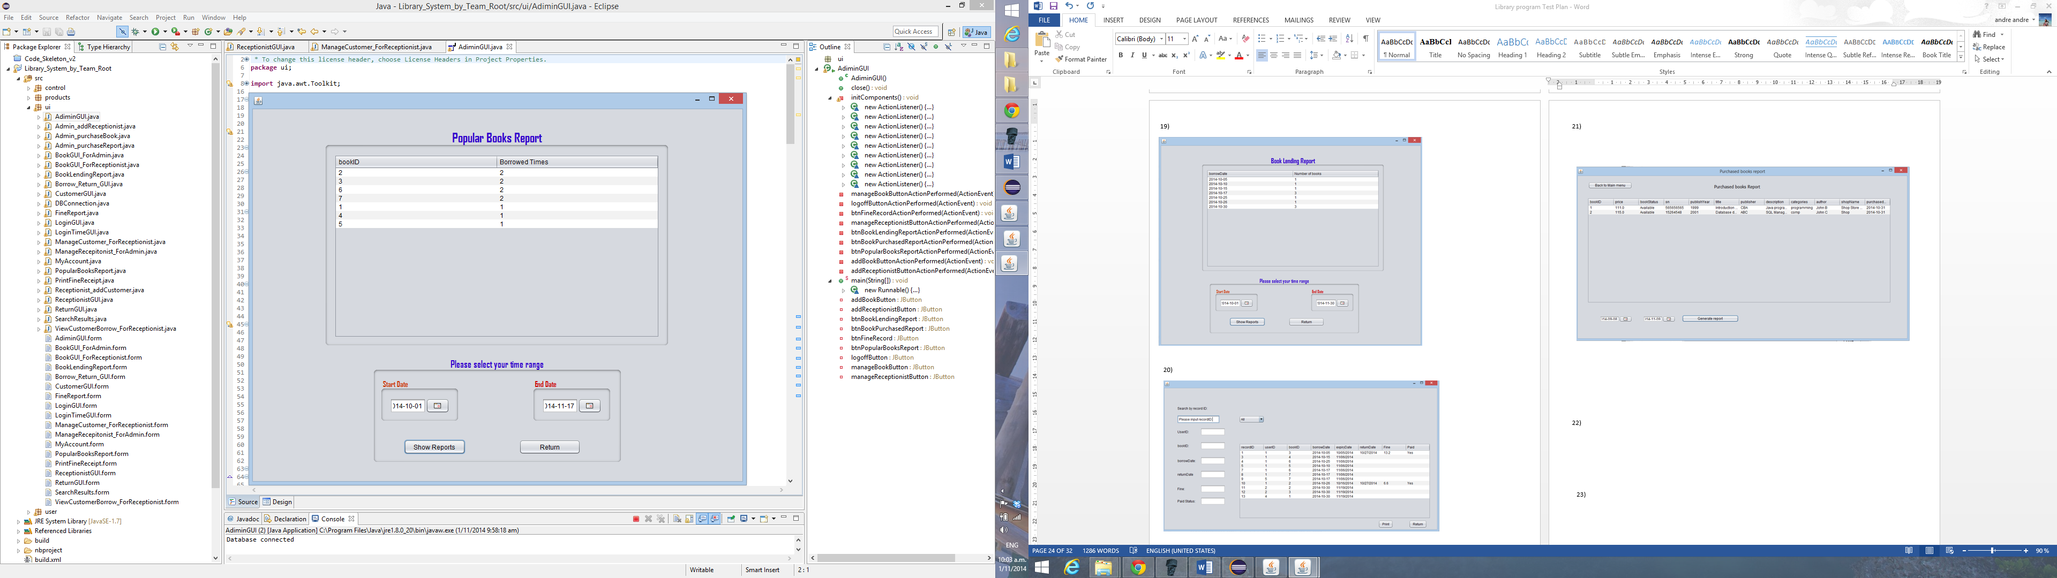

23)

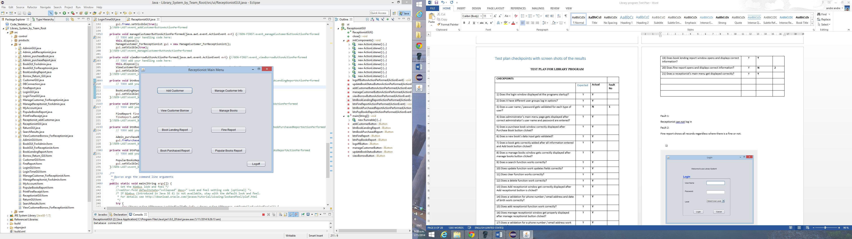

24)

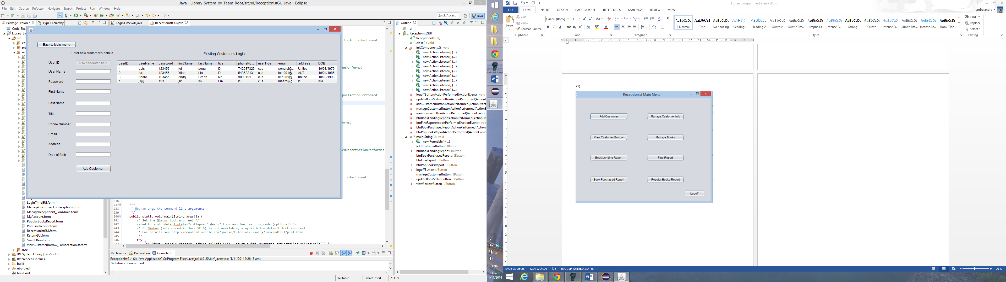

25)

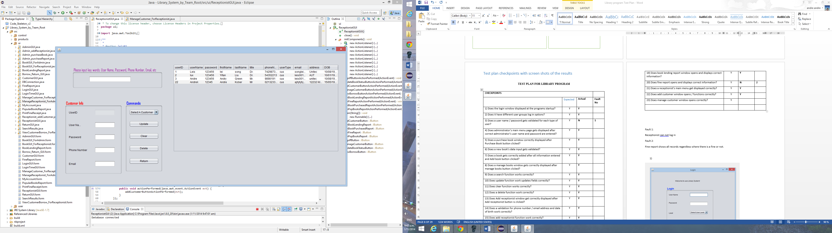

26)

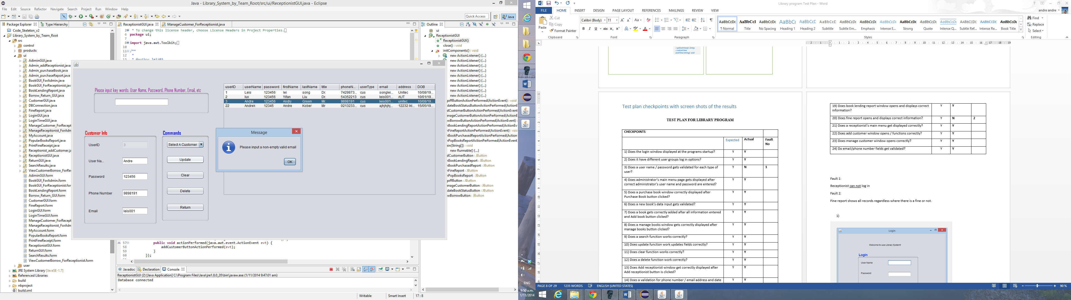

27)

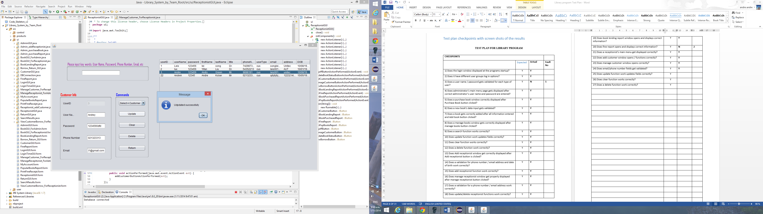

29)

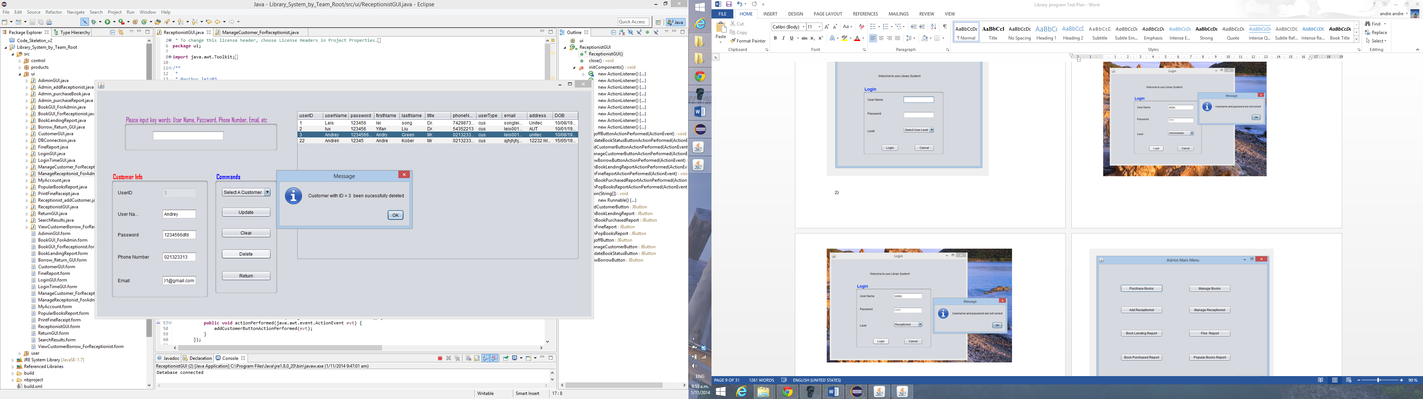

30)

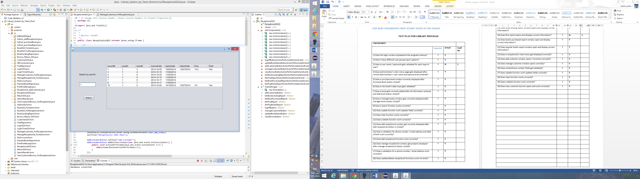

31)

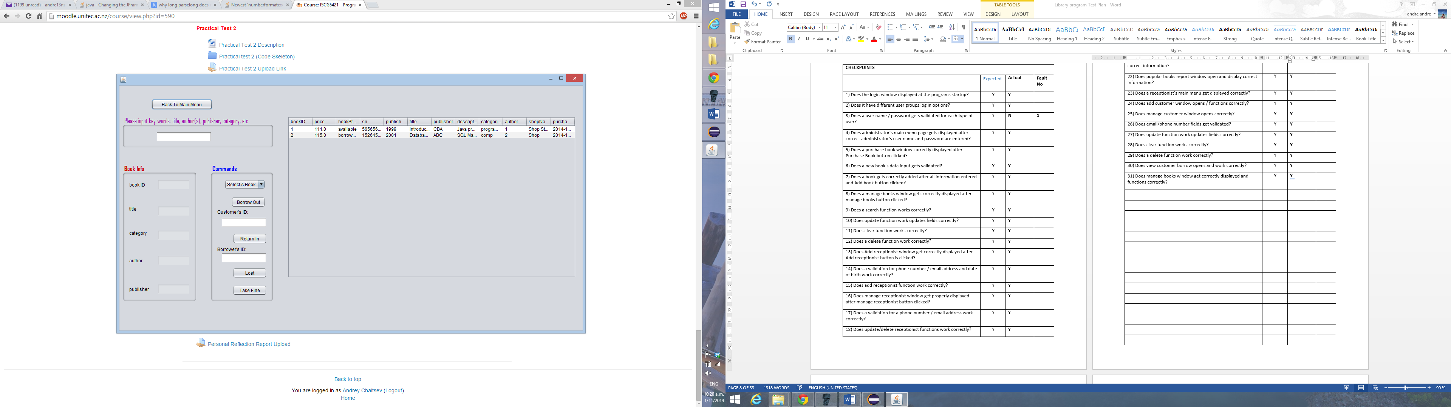

32)

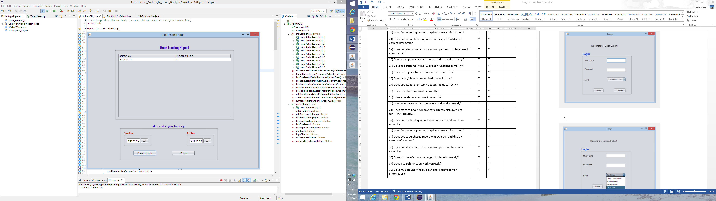

33)

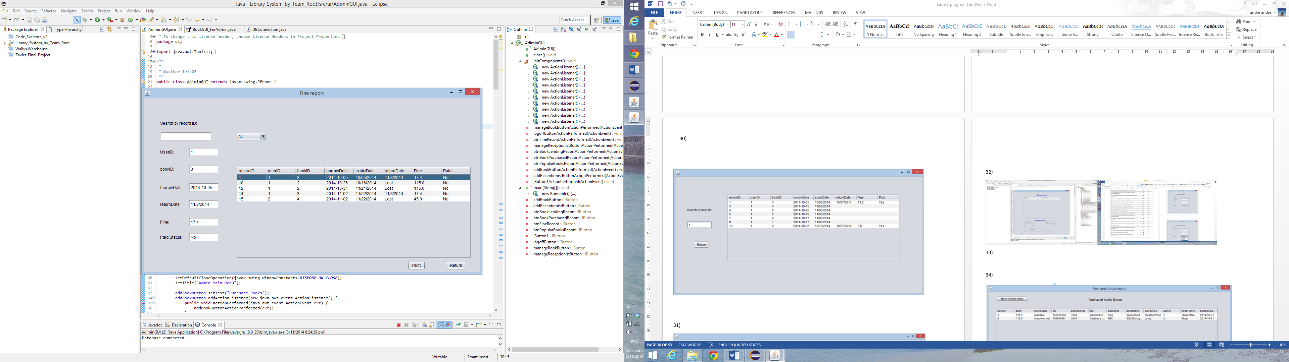

34)

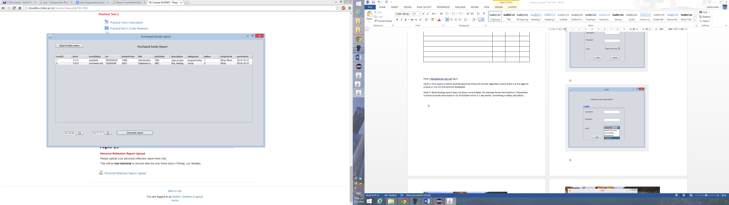

35)

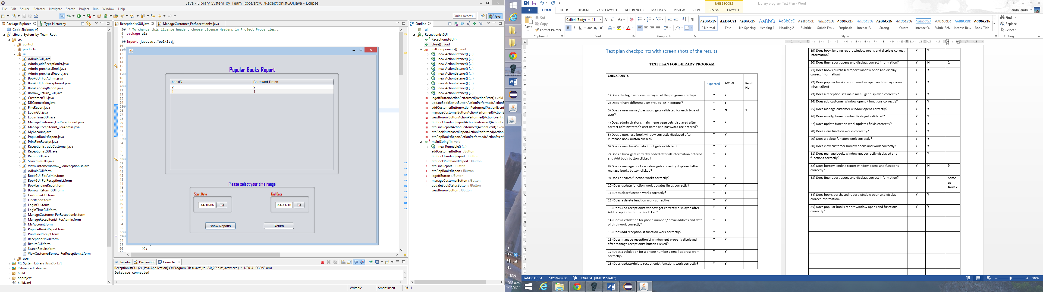

36)

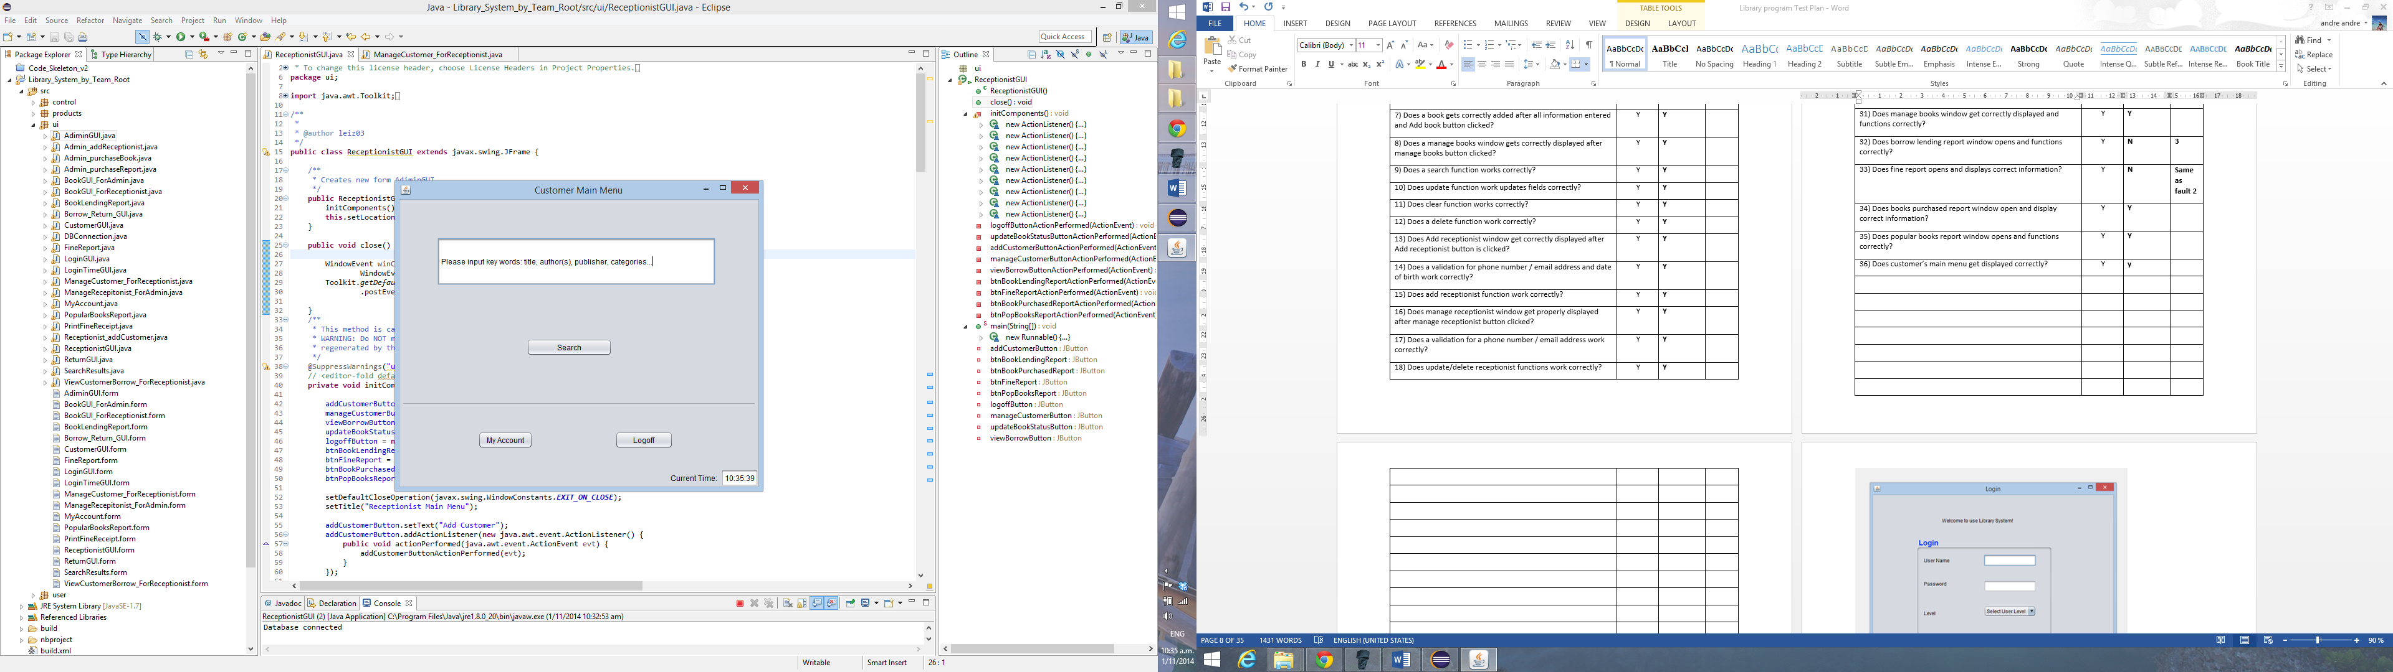

37)

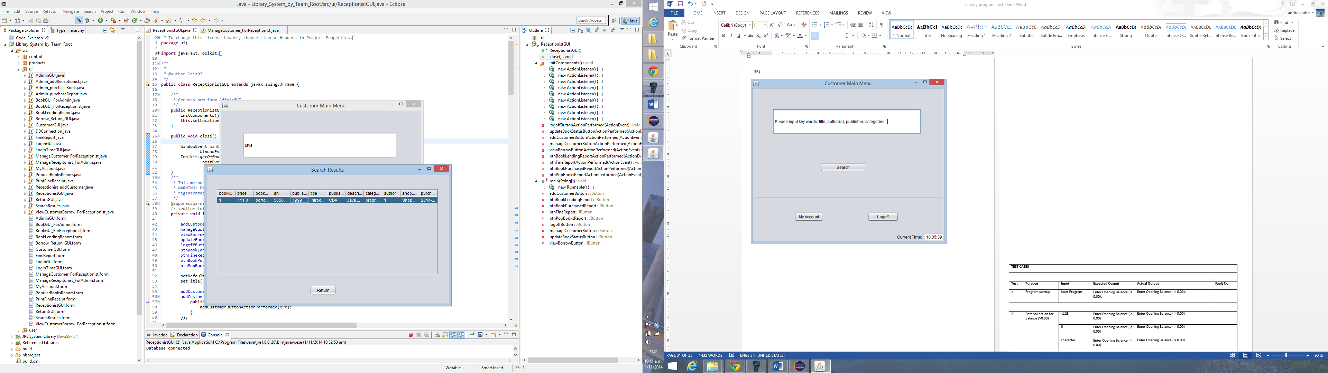

38)

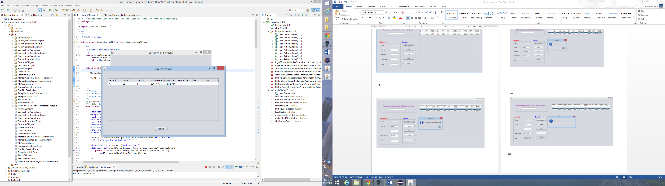

|  |  |  |  |  |  |
| --- | --- | --- | --- | --- | --- |
| **TEST CASES** | | | | |  |
|  | | | | |  |
| **Test** | **Purpose** | **Input** | **Expected Output** | **Actual Output** | **Fault No** |
|  | Program startup | Start Program | Login Page | Login Page |  |
|  | | | | |  |
|  | Data validation for customer’s user name / password.  Correct User name: Andrek  Correct password: 12345 | User Name: 123  Password: abc | Message: Username and passwords are not correct | Message: Username and passwords are not correct |  |
| User Name: Andrek  Password:  456 | Message: Username and passwords are not correct | Message: Username and passwords are not correct |  |
| User Name:  User  Password:  12345 | Message: Username and passwords are not correct | Message: Username and passwords are not correct |  |
| User Name:  Andrek  Password:  12345 | Customers main screen displayed | Customers main screen displayed |  |
|  | | | | |  |
|  | Data validation for receptionists’ user name / password.  Correct User name: AlisonD  Correct password: 123456 | User Name: 123  Password: abc | Message: Username and passwords are not correct | Message: Username and passwords are not correct |  |
| User Name: AlisonD  Password:  456 | Message: Username and passwords are not correct | Message: Username and passwords are not correct |  |
| User Name:  User  Password:  123456 | Message: Username and passwords are not correct | Message: Username and passwords are not correct |  |
| User Name:  AlisonD  Password:  123456 | Receptionist’s main screen displayed | Customers main screen displayed |  |
|  | | | | |  |
|  | Data validation for administrator’s user name / password.  Correct User name:  Jim001  Correct password:  123 | User Name: Jim  Password: 123 | Message: Username and passwords are not correct | Message: Username and passwords are not correct |  |
| User Name: Jim001  Password:  456 | Message: Username and passwords are not correct | Message: Username and passwords are not correct |  |
| User Name:  User  Password:  123 | Message: Username and passwords are not correct | Message: Username and passwords are not correct |  |
| User Name:  Jim001  Password:  123 | Administrators’ main screen displayed | Customers main screen displayed |  |
|  | | | | |  |
|  | Purchase Books data input validation | Book Price:  Abc | Please enter a correct price ($1-$1000) | Please enter a correct price ($1-$1000) |  |
| Book Price:  -20 | Please enter a correct price ($1-$1000) | Please enter a correct price ($1-$1000) |  |
| Book Price:  5000 | Please enter a correct price ($1-$1000) | Please enter a correct price ($1-$1000) |  |
| Year published:  abc | Please enter a correct published year | Please enter a correct published year |  |
| Year published:  1200 | Please enter a correct published year | Please enter a correct published year |  |
| Year published:  -2014 | Please enter a correct published year | Please enter a correct published year |  |
|  | | | | |  |
|  | Manage books search function testing | Book status:  Lost | Book with bookID 2 | Book with bookID 2 |  |
| Description  SQL | Book with bookID 2 | Book with bookID 2 |  |
|  | | | | |  |
|  | Add a receptionist input validation | Phone number:  abc | Please enter a correct phone number including an arear code (eg 092728888) | Please enter a correct phone number including an arear code (eg 092728888) |  |
| Phone number:  -095647899 | Please enter a correct phone number including an arear code (eg 092728888) | Please enter a correct phone number including an arear code (eg 092728888) |  |
| Phone number:  095647899 | Phone number successfully accepted | Phone number successfully accepted |  |
| Email:  Abc | Please input a non-empty valid email | Please input a non-empty valid email |  |
| Email:  andre@ | Please input a non-empty valid email | Please input a non-empty valid email |  |
| Email:  Andre@gmail.com | Email address successfully accepted | Email address successfully accepted |  |
| DOB:  ABC | Please input a date of birth in this format:  dd/MM/YYYY | Please input a date of birth in this format:  dd/MM/YYYY |  |
| DOB:  12 January | Please input a date of birth in this format:  dd/MM/YYYY | Please input a date of birth in this format:  dd/MM/YYYY |  |
| DOB:  12/01/1986 | New receptionist added message | New receptionist added message |  |
|  | | | | |  |
|  | Manage receptionist search function / input validation | Search field: AlisonD | User with ID 20 | User with ID 20 |  |
| Search field:  donnowel | User with ID 20 | User with ID 20 |  |
| Changing phone number for user with ID 20:  -092568799 | Please input valid phone numbers with only digit numbers | Please input valid phone numbers with only digit numbers |  |
| Changing an email address:  alison@ | Please input a non-empty valid email | Please input a non-empty valid email |  |
|  | | | | |  |
|  | Scenario test with Purchase a book, manage books/ purchase book report | Purchasing a new book (bookID: 4) | Book successfully added and displayed in existing book table | Book successfully added and displayed in existing book table |  |
| Find a book and change title / category / author / publisher. | Book’s details successfully updated and displayed in existing book’s table. | Book’s details successfully updated and displayed in existing book’s table. |  |
| Produce a purchased books report. | Book with bookId 4 to clearly show on the report with all changes done at the previous step. | Book with bookId 4 to clearly show on the report with all changes done at the previous step. |  |
|  | Scenario with Add receptionist / Manage receptionist / Customer time spent report. | Add a new receptionist | Confirmation window that a new receptionist has been added and a new record displayed in existing receptionist’s logins table. | Confirmation window that a new receptionist has been added and a new record displayed in existing receptionist’s logins table. |  |
| Change receptionist’s user name / password / phone number / email | Confirmation window that record has been updated an new details are displaying in the table. | Confirmation window that record has been updated an new details are displaying in the table. |  |
| Log in as receptionist using updated details:  TomS / qwerty.  Log in using administrator’s log in and check user time spent report. | Record of user with user ID 22 logged in the system. | Record of user with user ID 22 logged in the system. |  |
|  | Scenario with Borrowing a book/view customer borrow/book lending report/popular books report. | Borrow out a book with ID: 4 to a customer with ID 1. | A confirmation message showing that a book has been borrowed out. A status of the book changed to borrowed out. | A confirmation message showing that a book has been borrowed out. A status of the book changed to borrowed out. |  |
| Test Customer Borrow report. | A record of the book ID 4 has been borrowed to a user with ID1. | A record of the book ID 4 has been borrowed to a user with ID1. |  |
| Test book lending report for today’s date. | A record of quantity of books lended today (correct record – 1 book). | A record of quantity of books lended today (correct record – 1 book). |  |
| Test popular books report | Book ID 4 to be shown on the report. | Book ID 4 to be shown on the report. |  |

1)

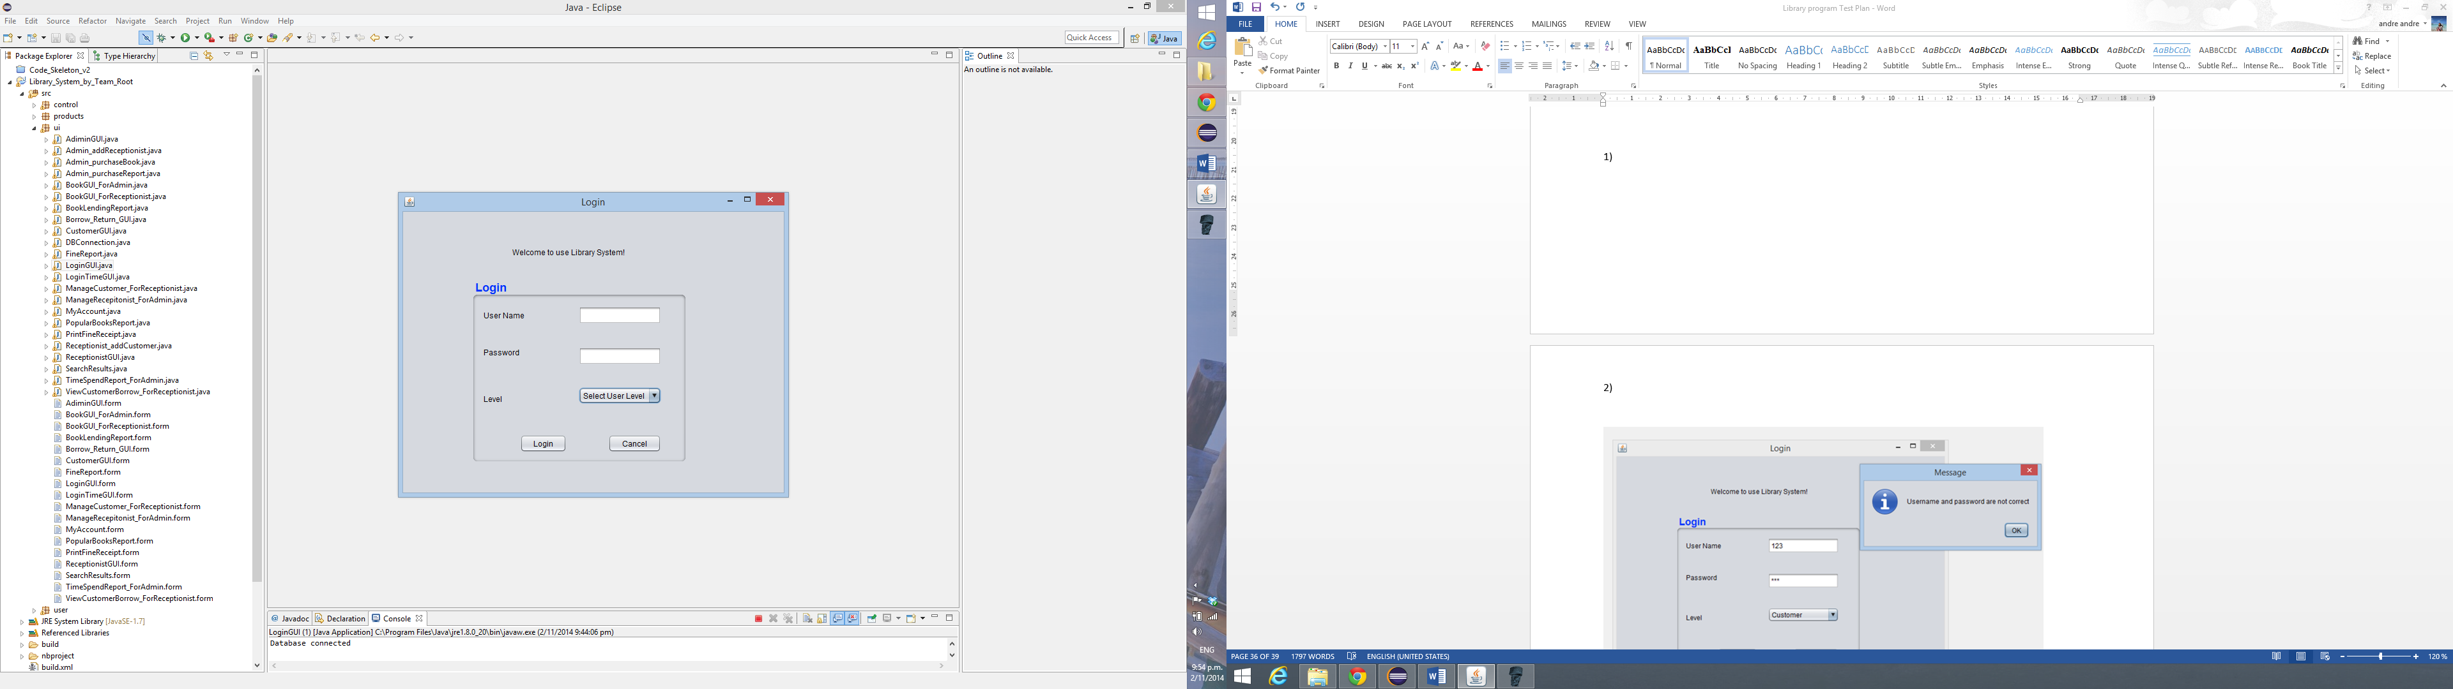

2)

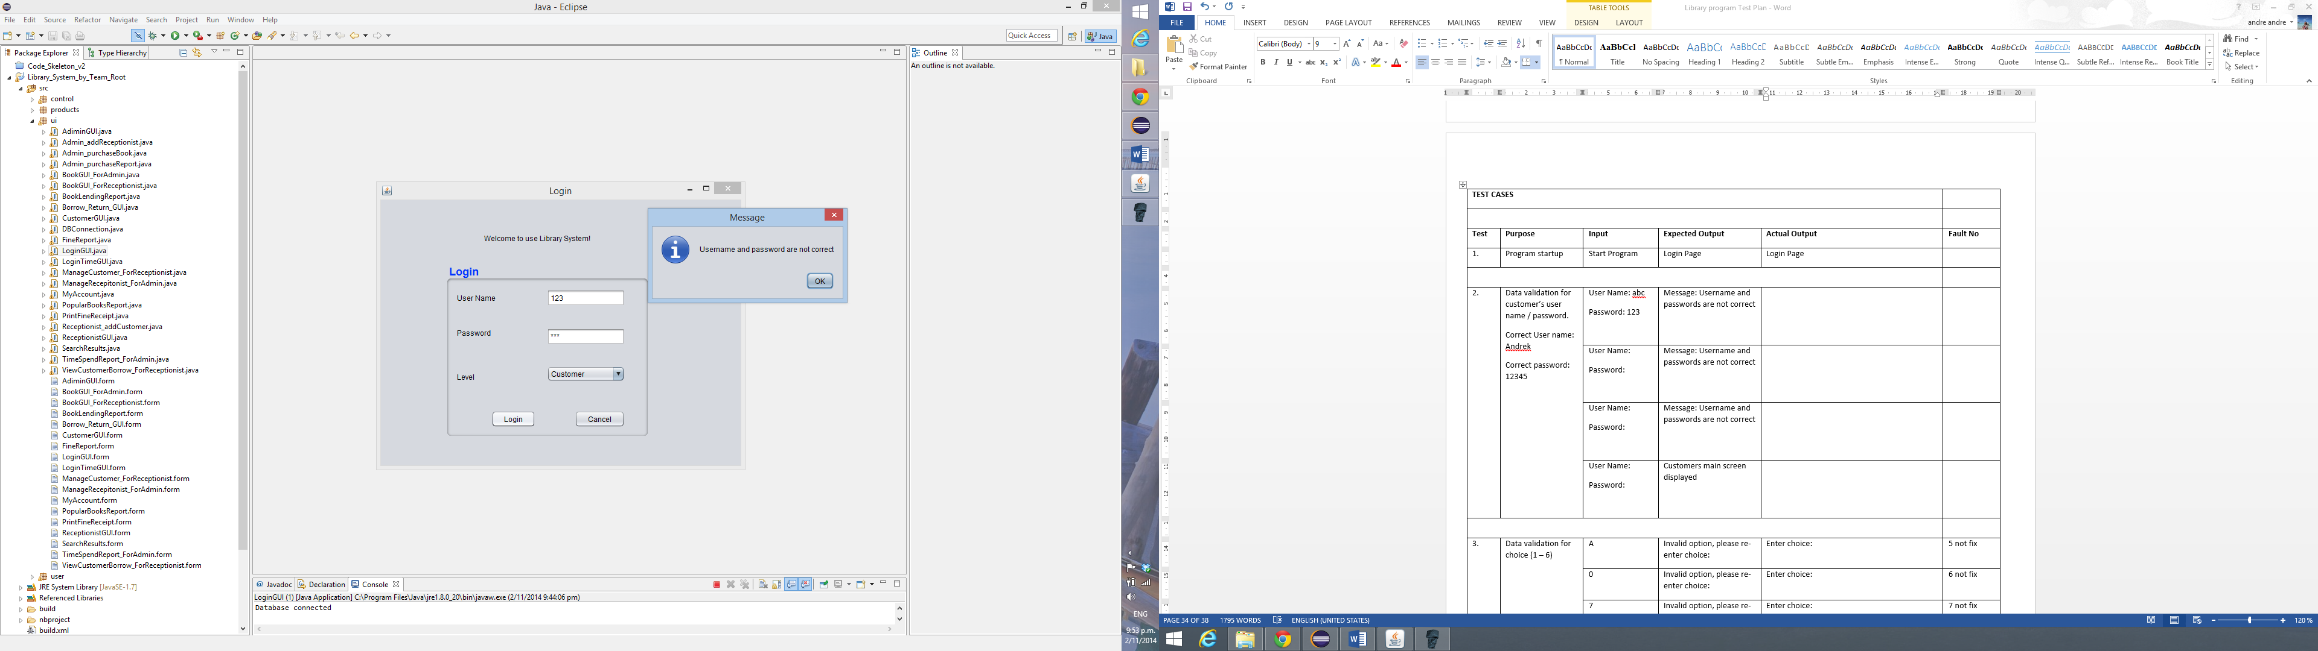

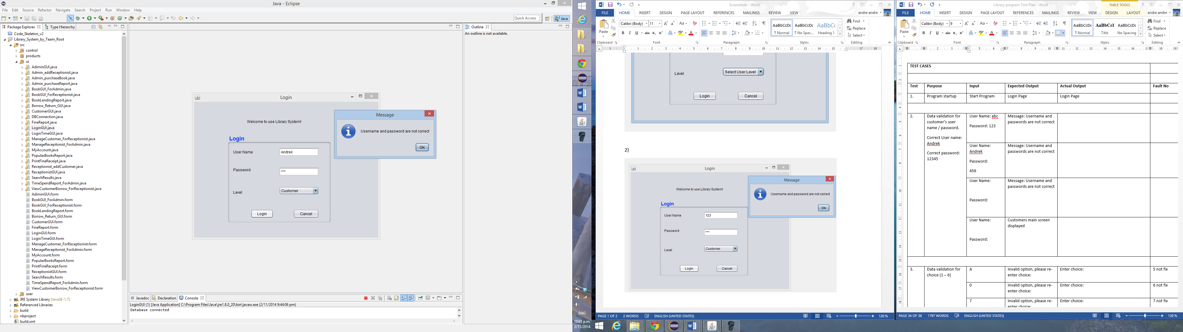

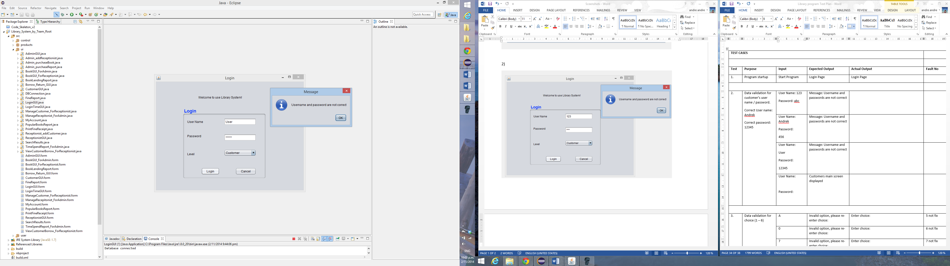

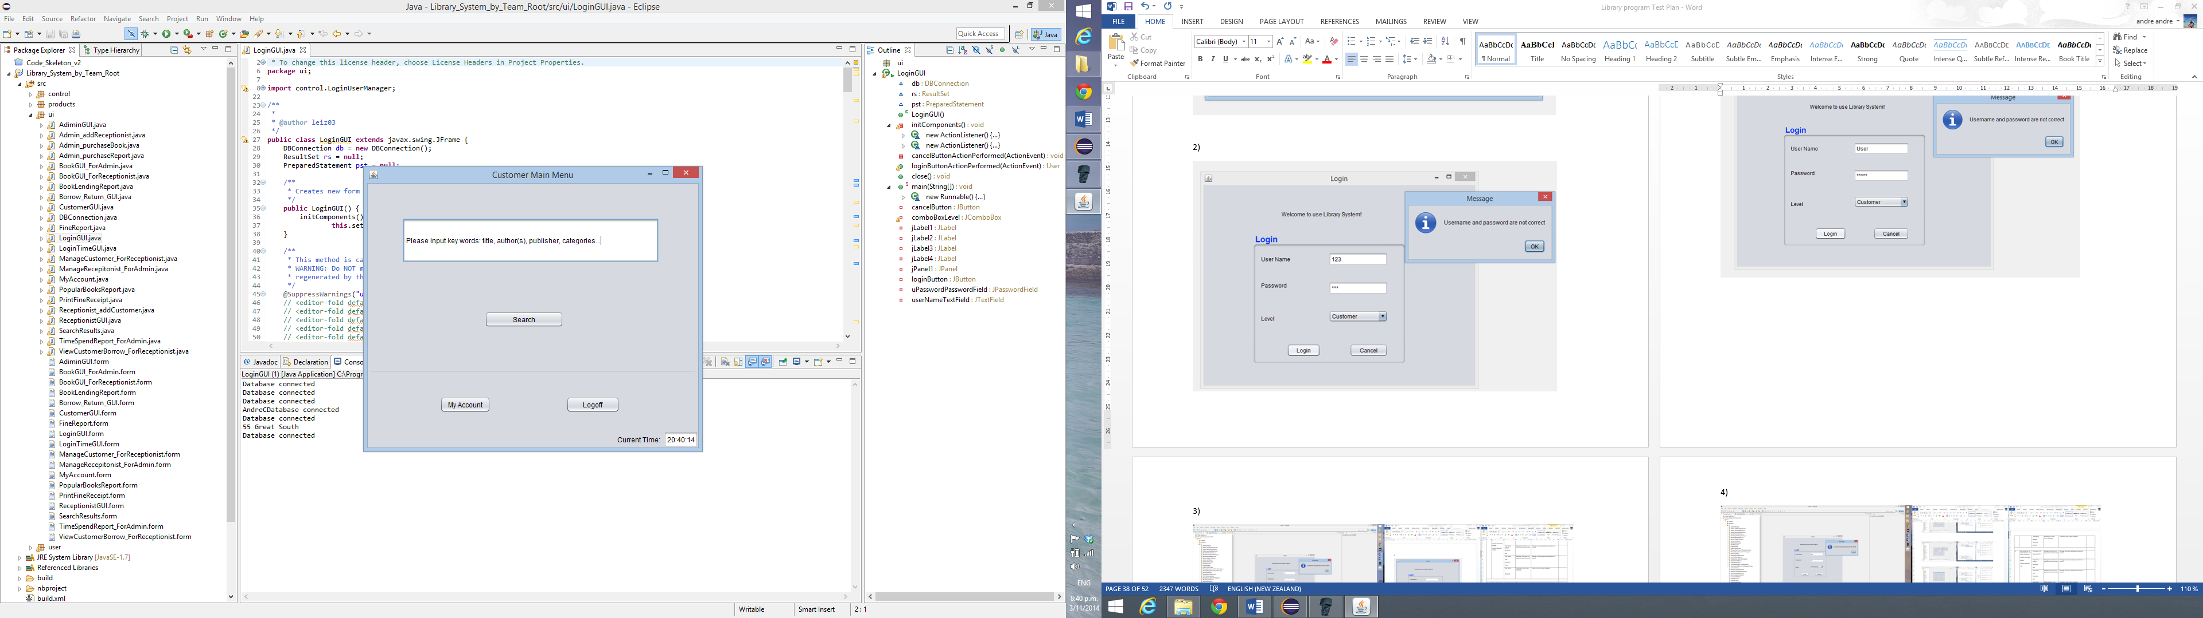

3)

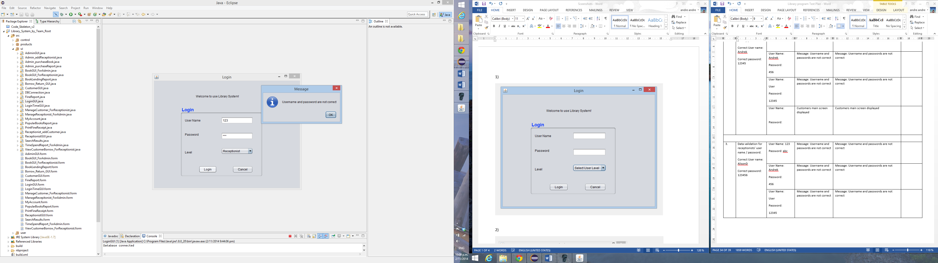

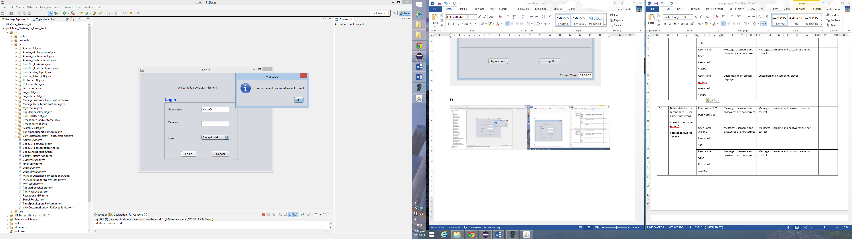

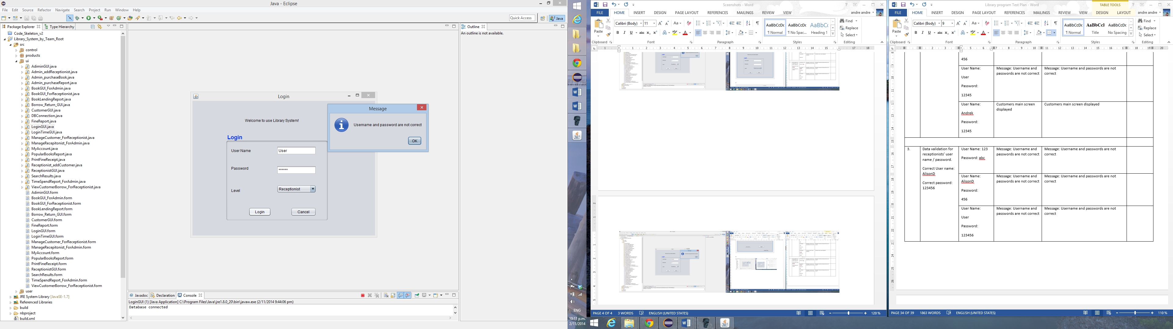

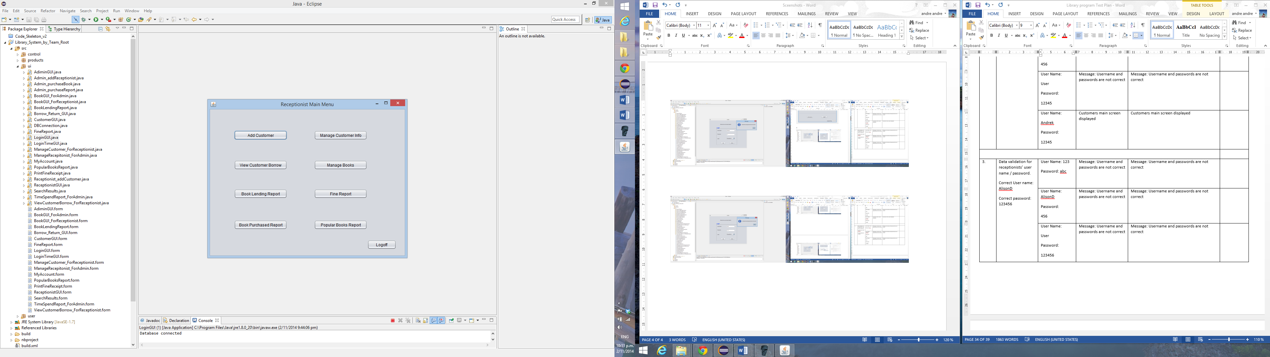

4)

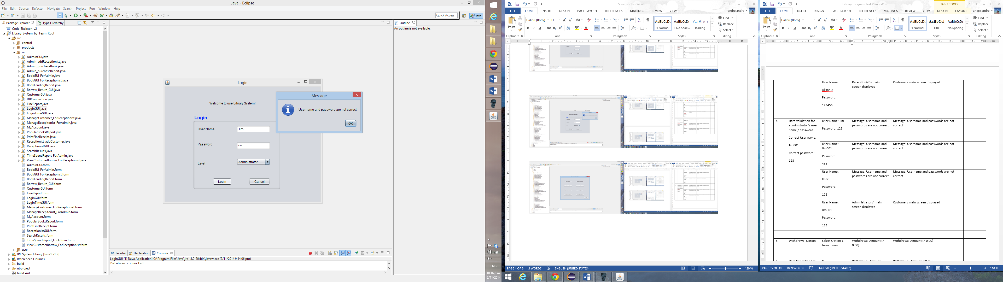

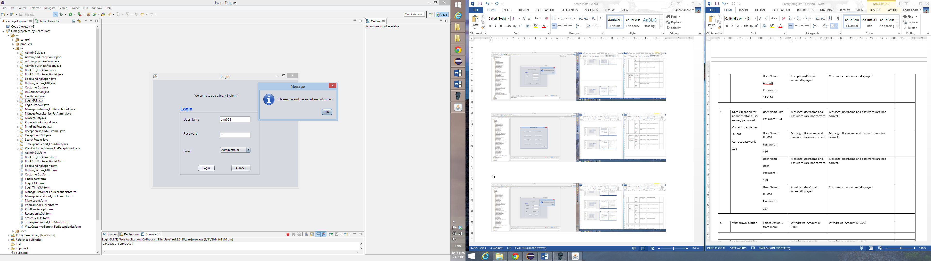

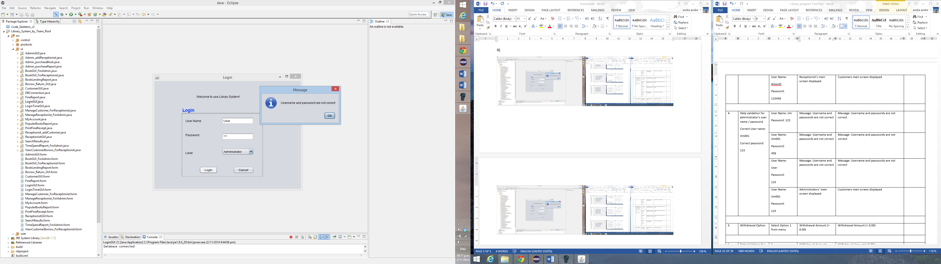

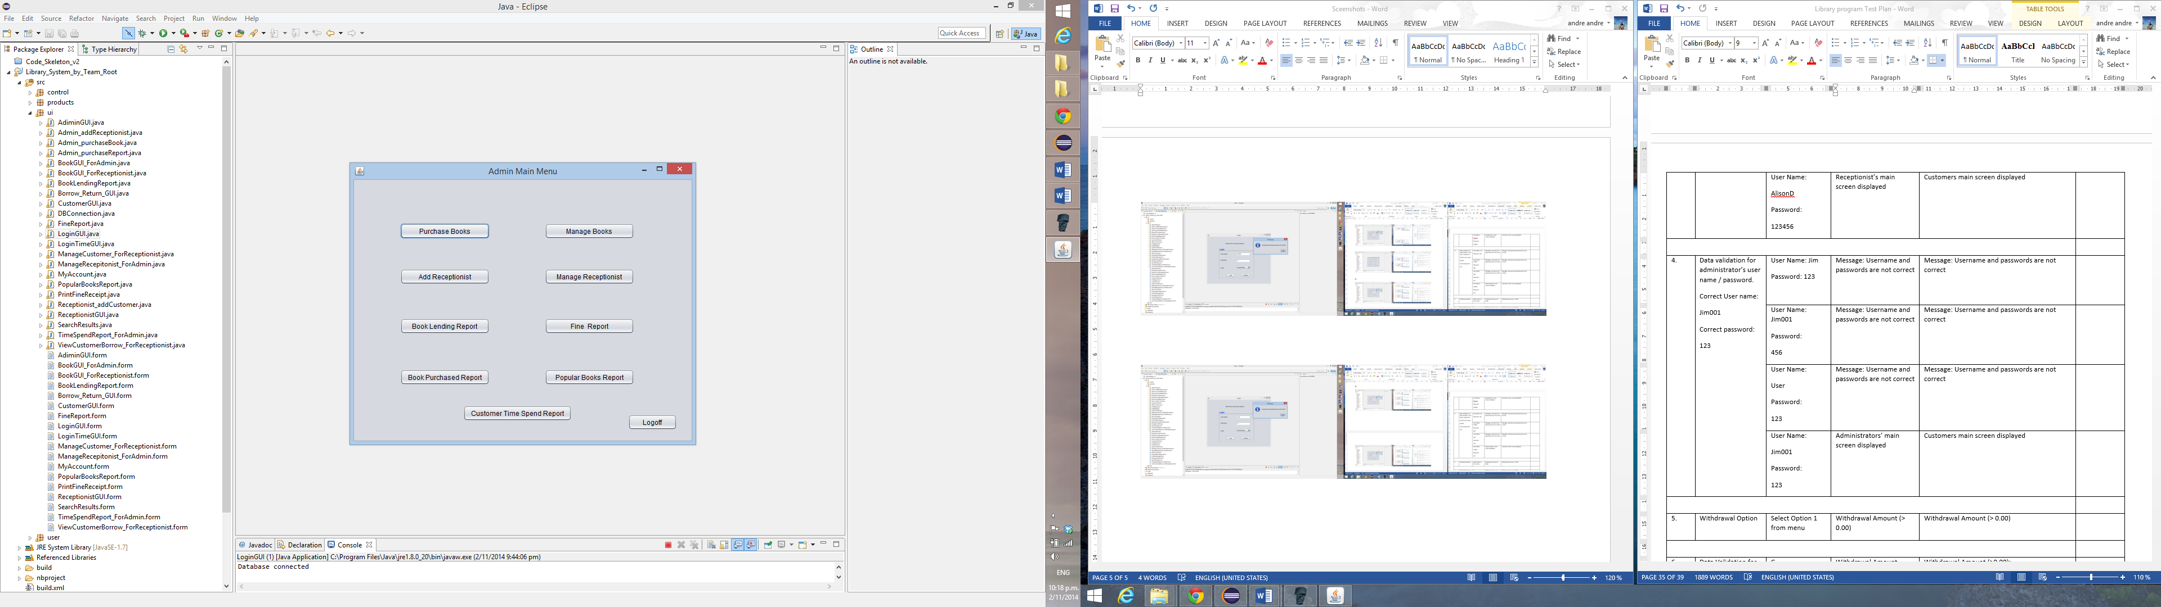

5)

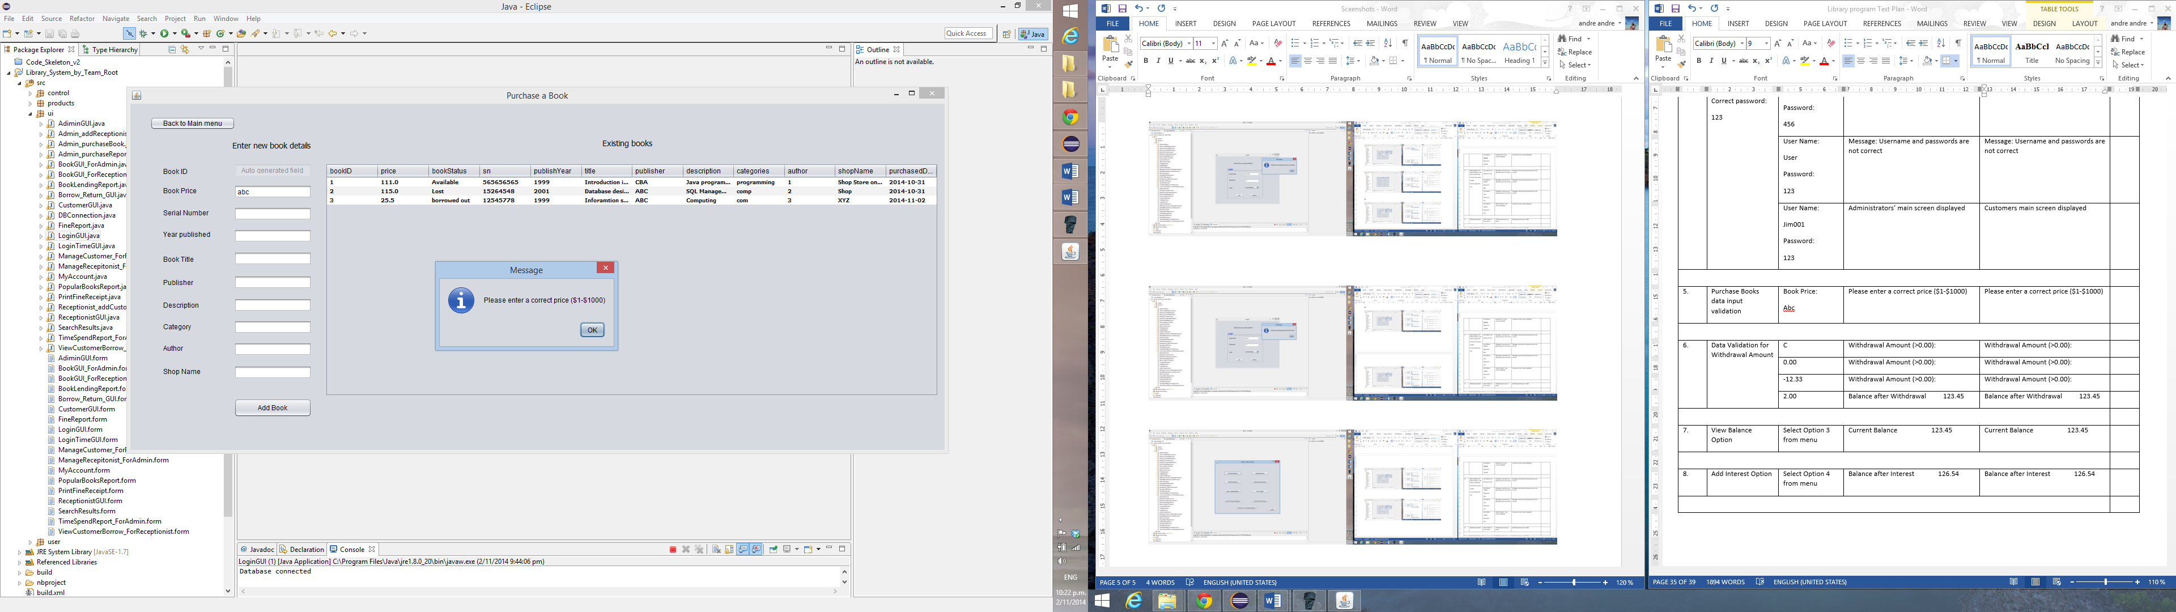

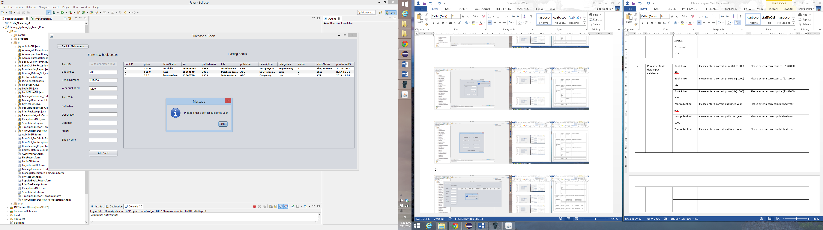

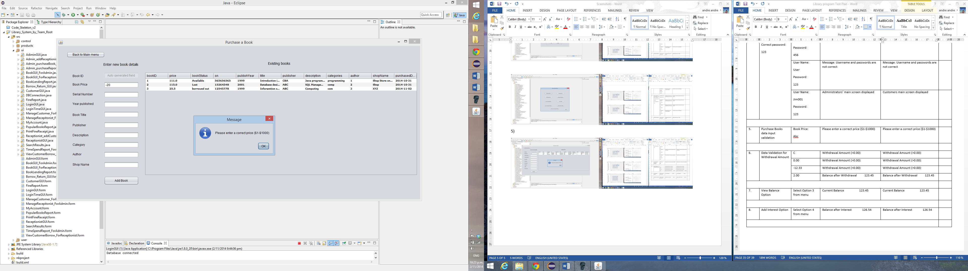

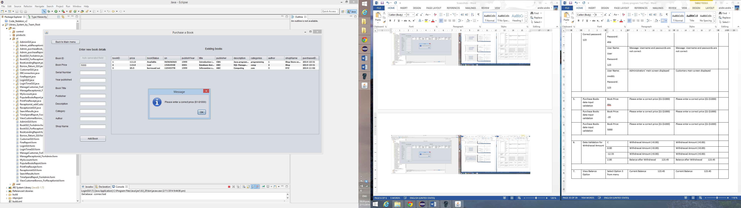

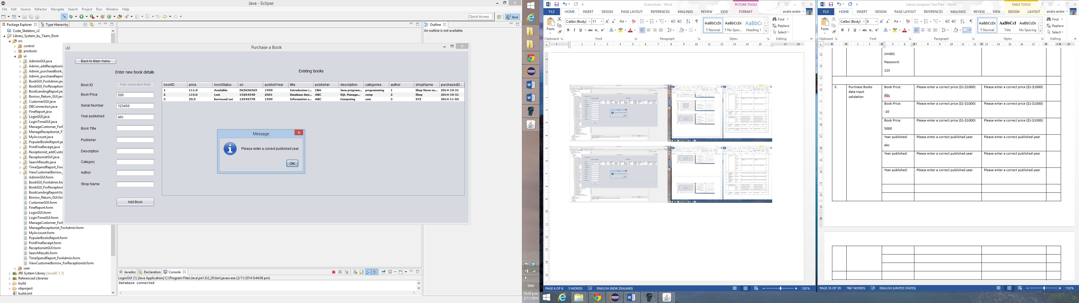

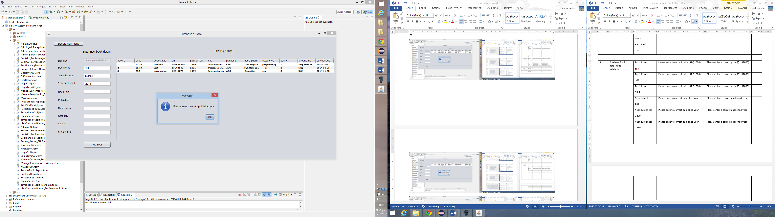

6)

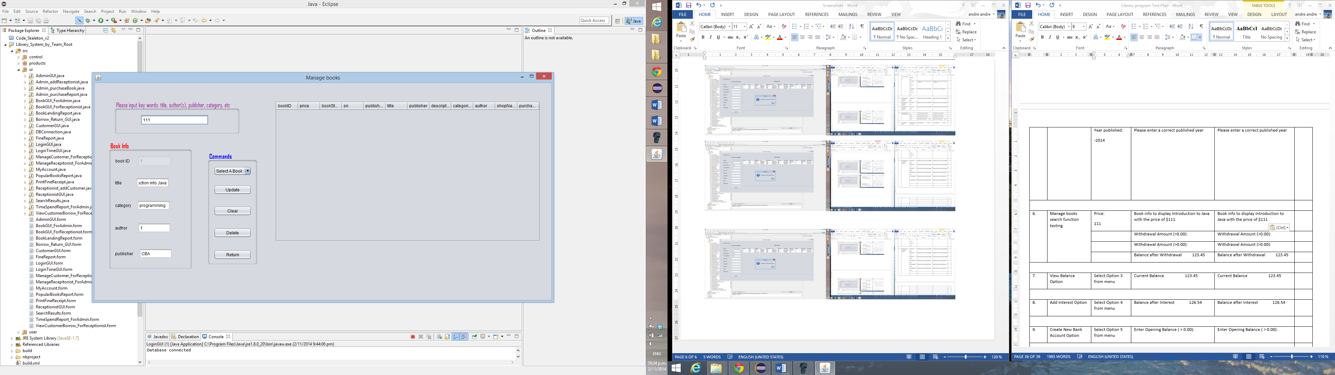

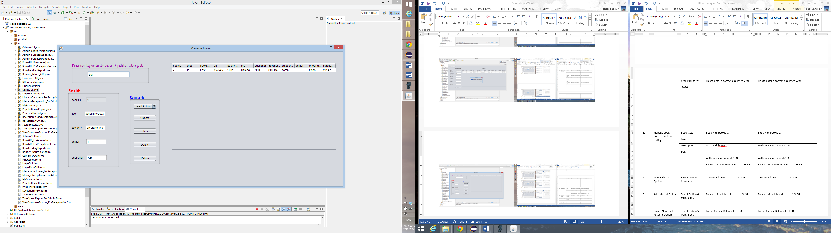

7)

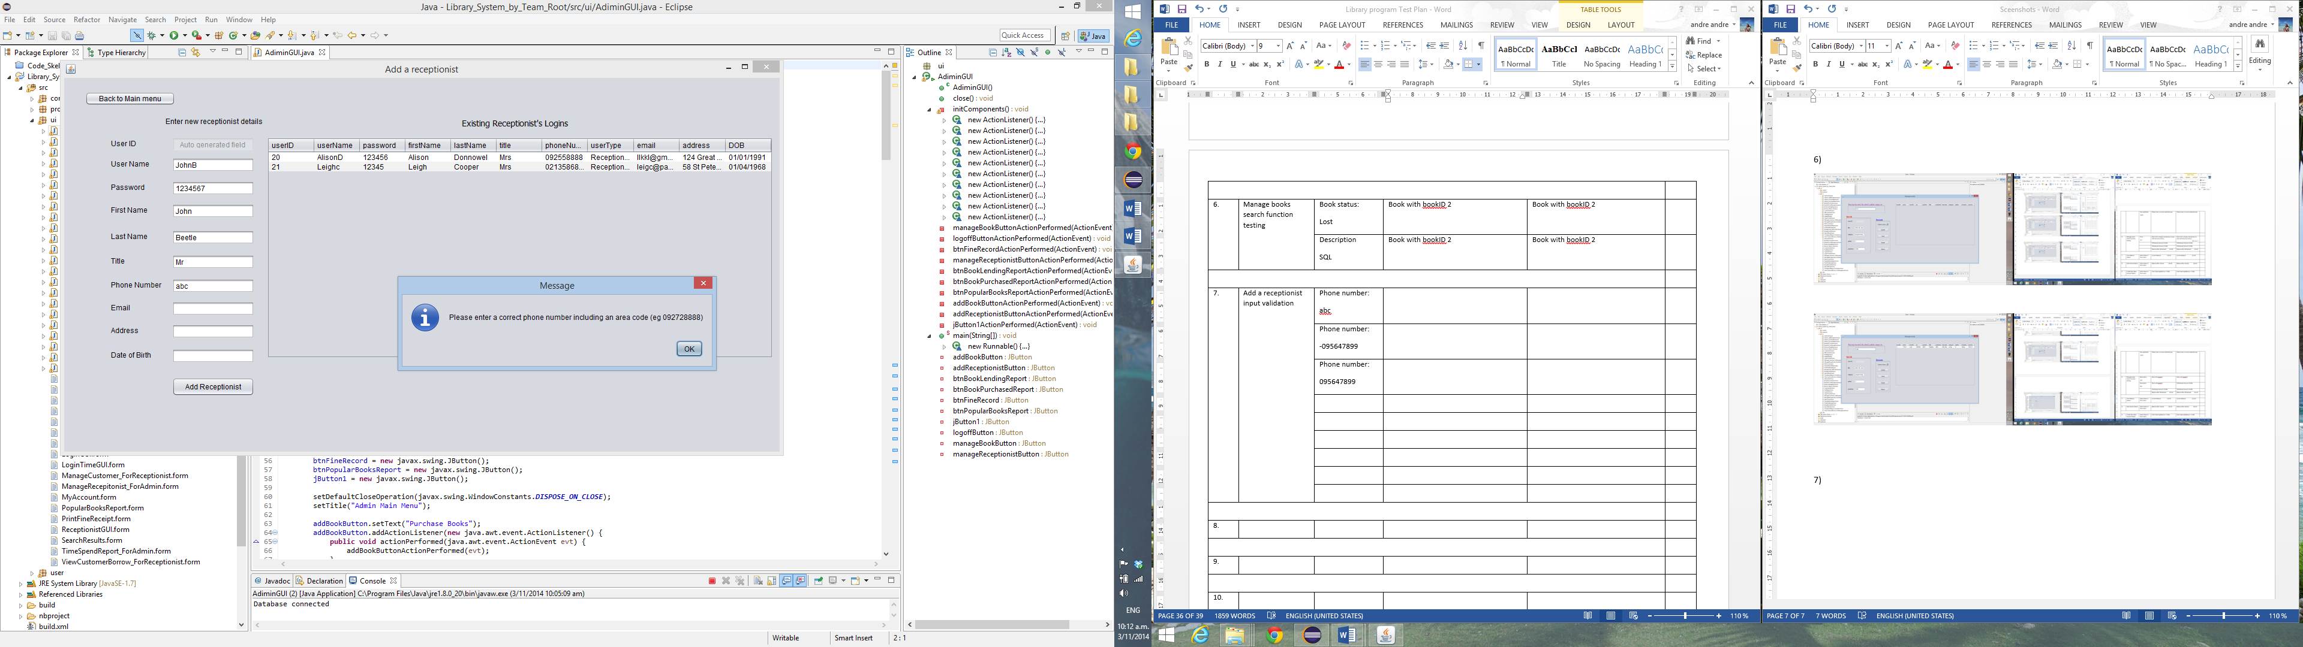

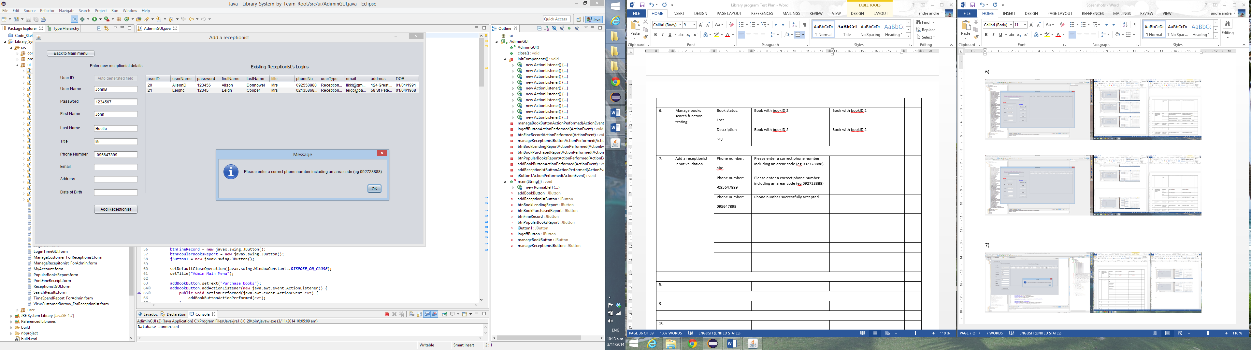

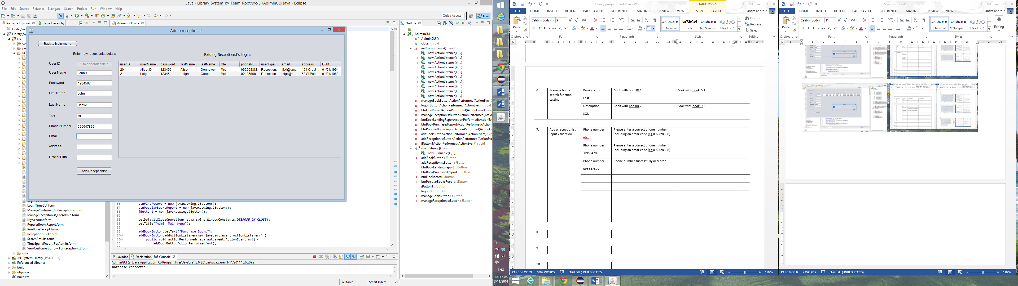

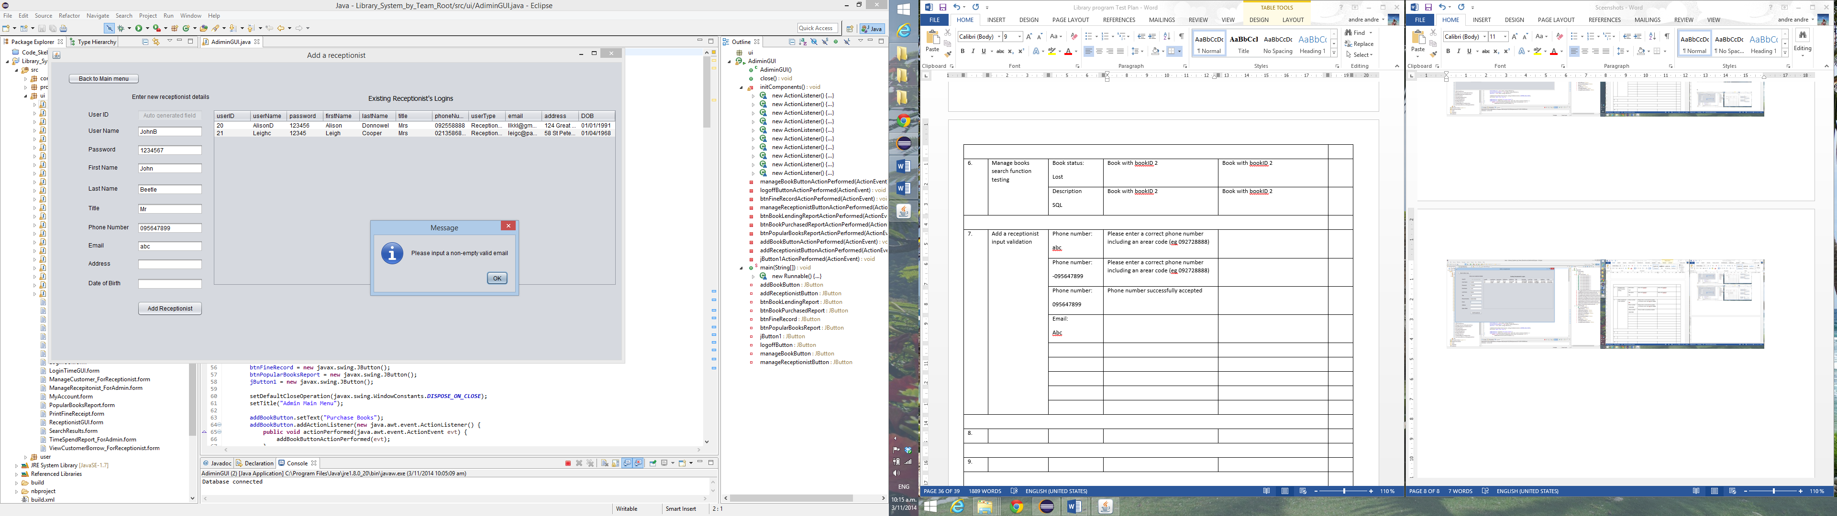

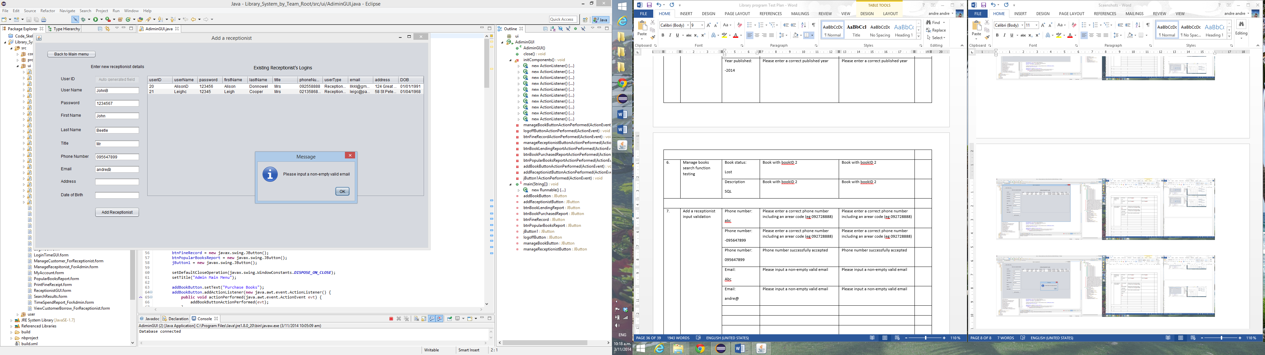

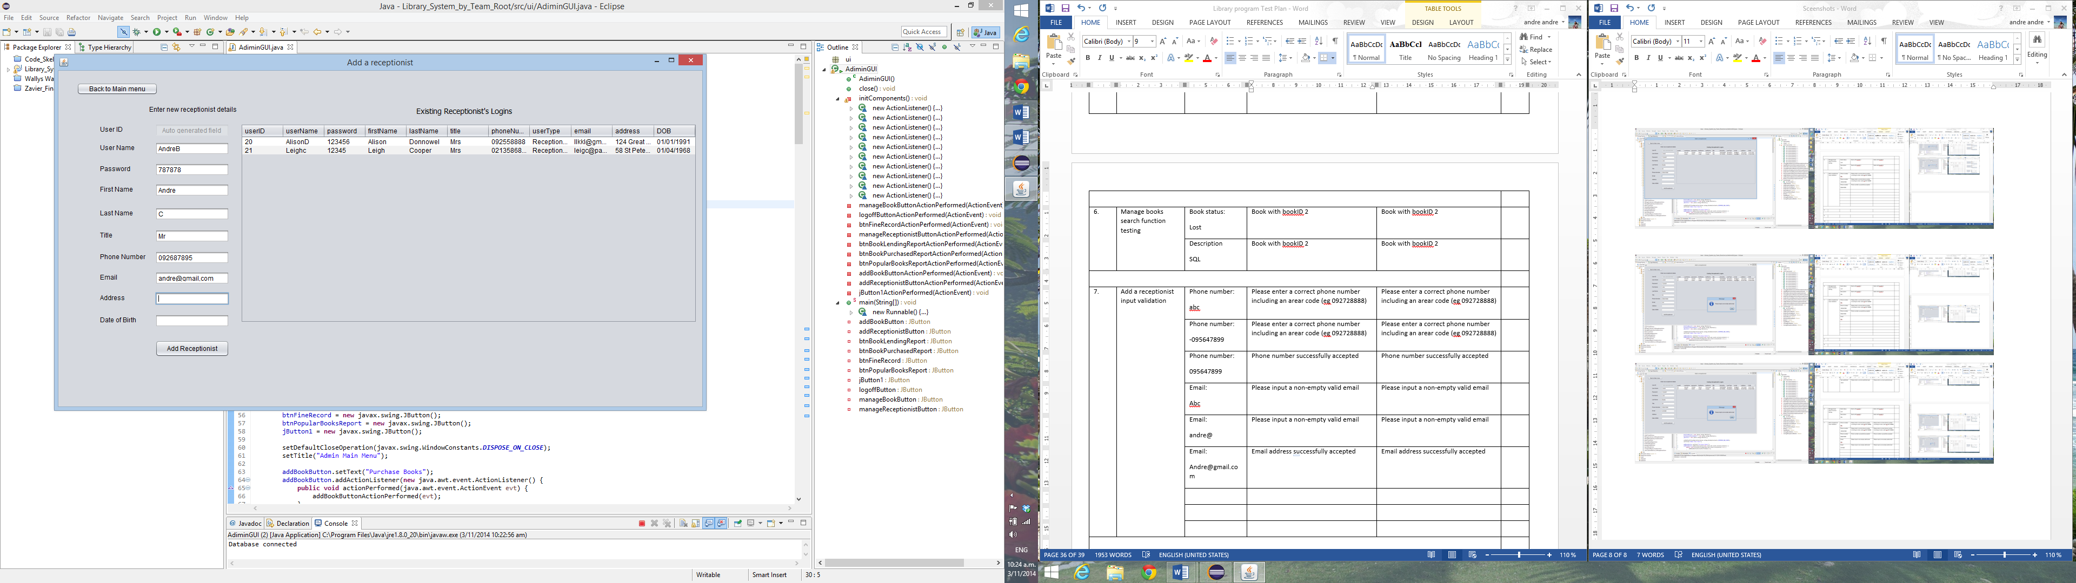

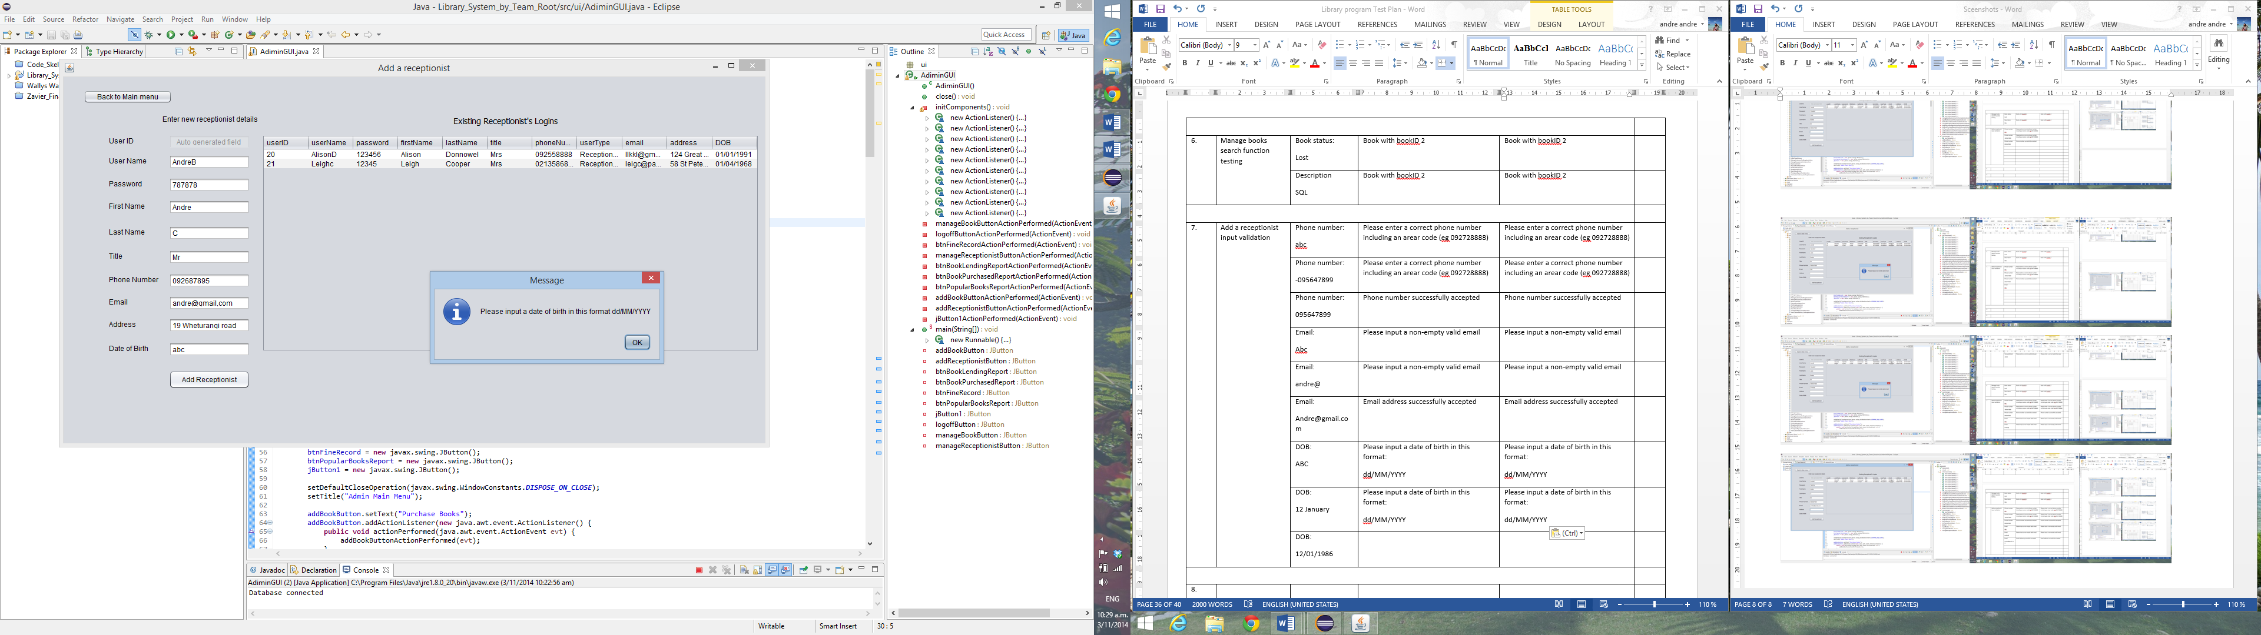

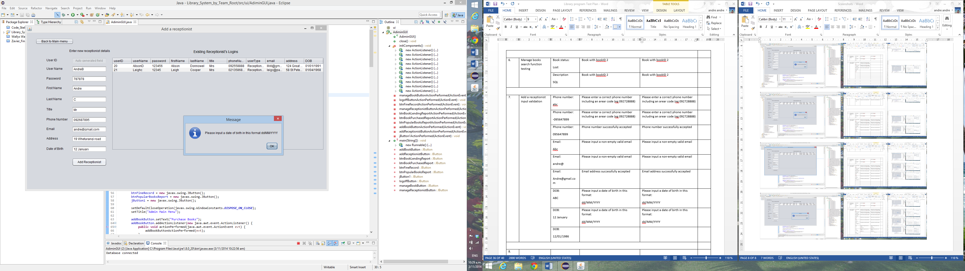

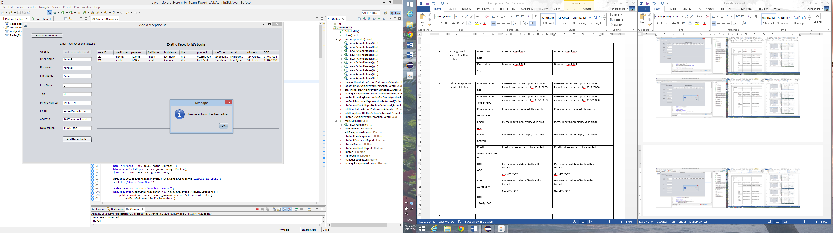

8)

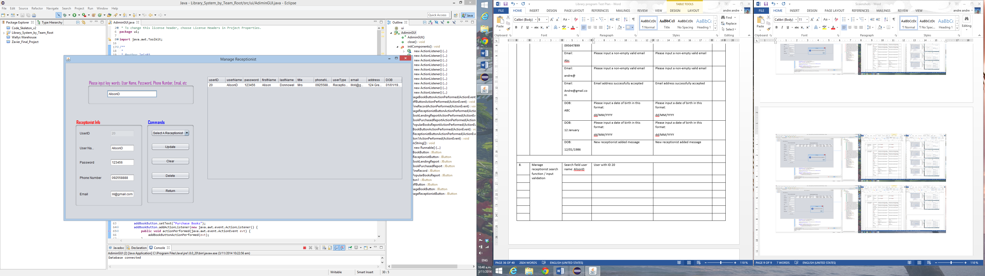

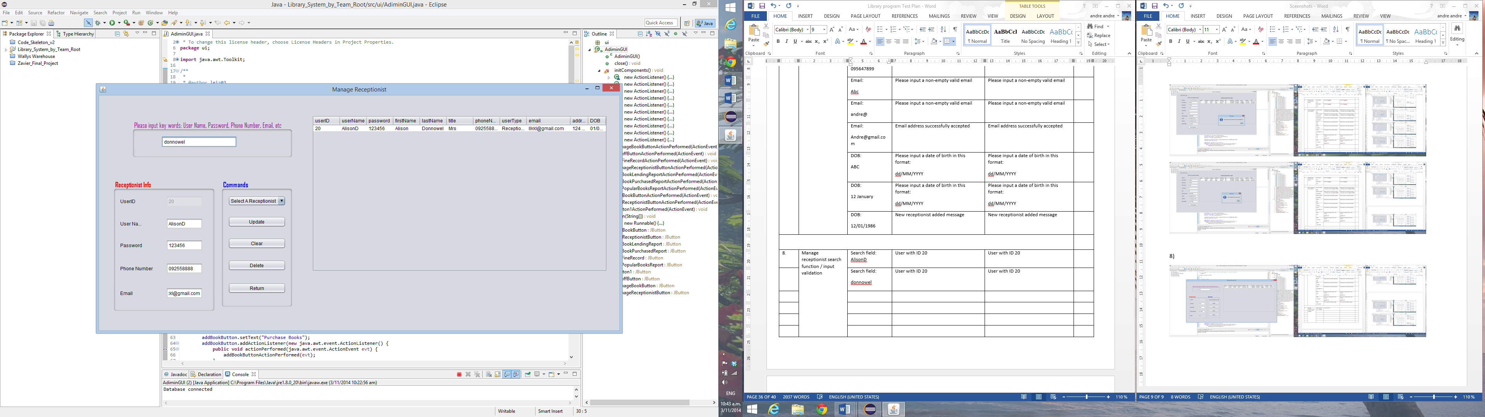

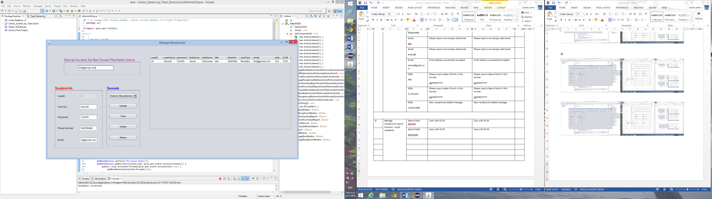

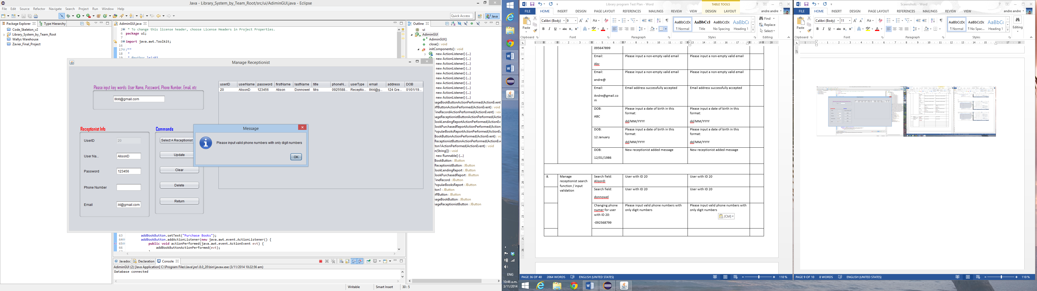

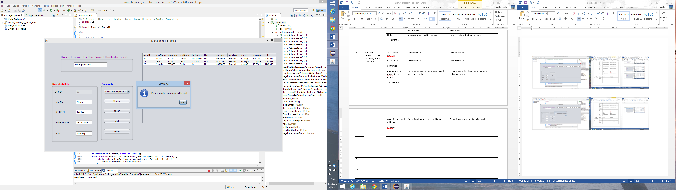

9)

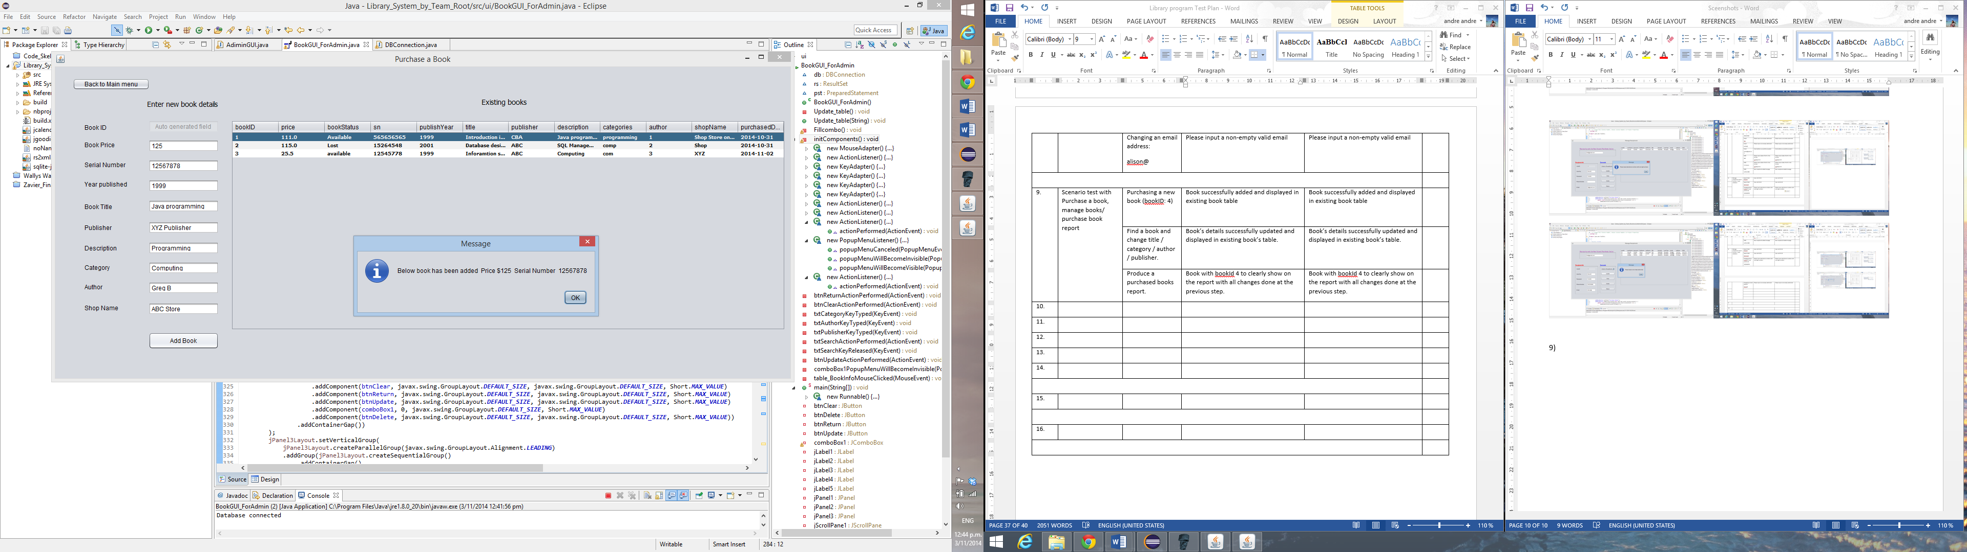

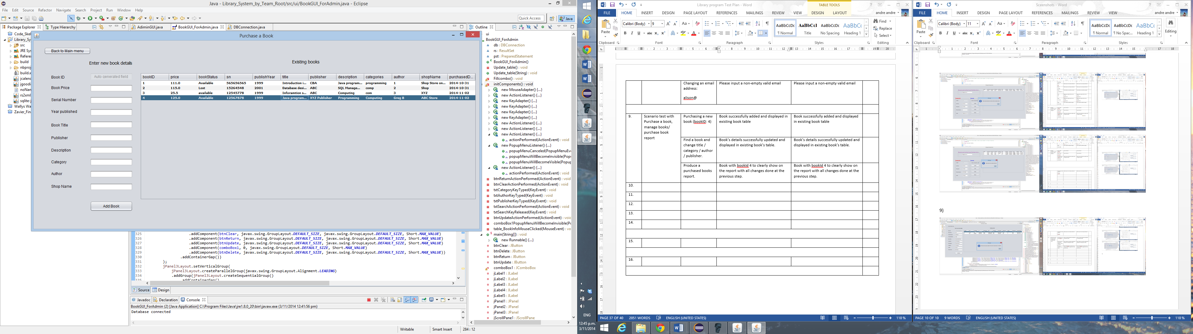

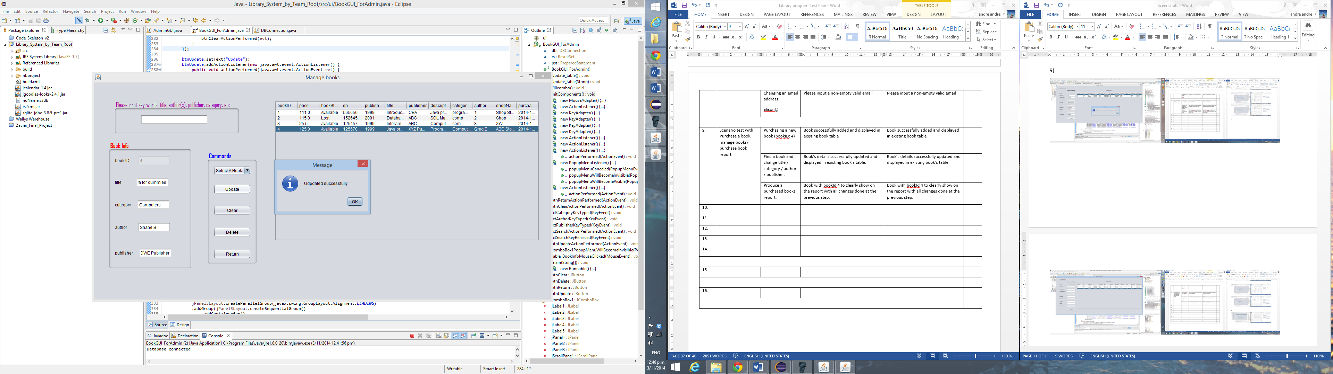

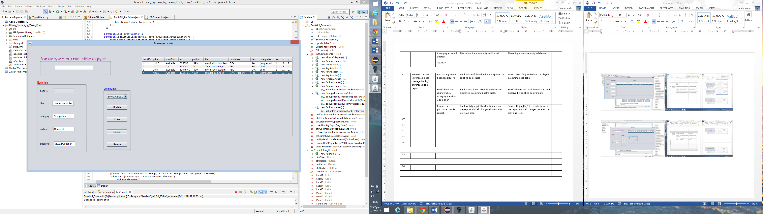

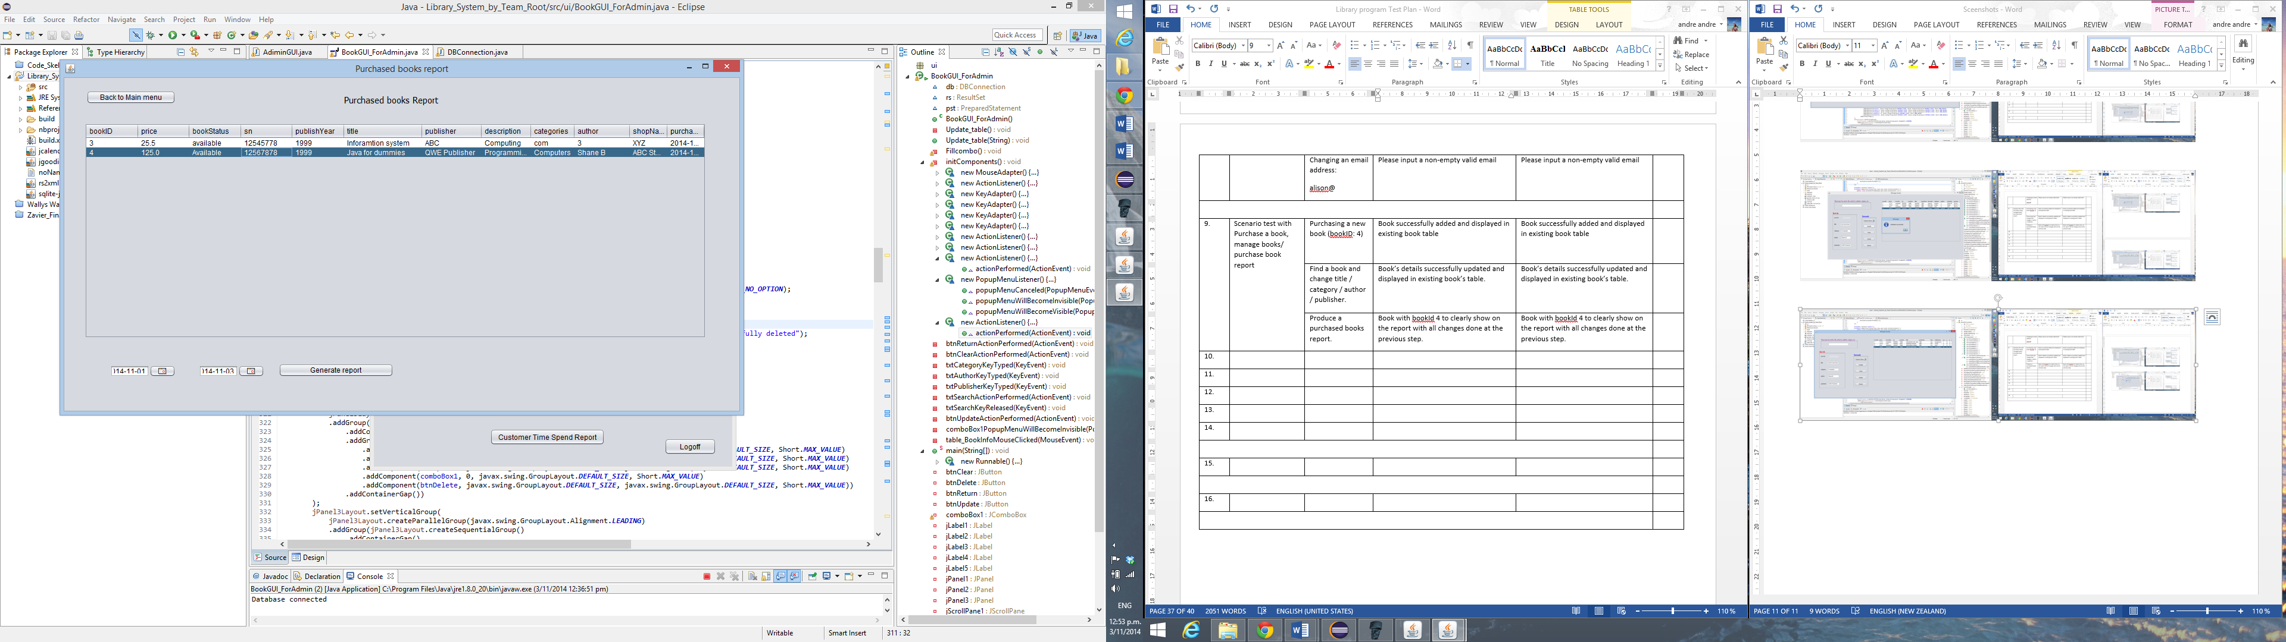

10)

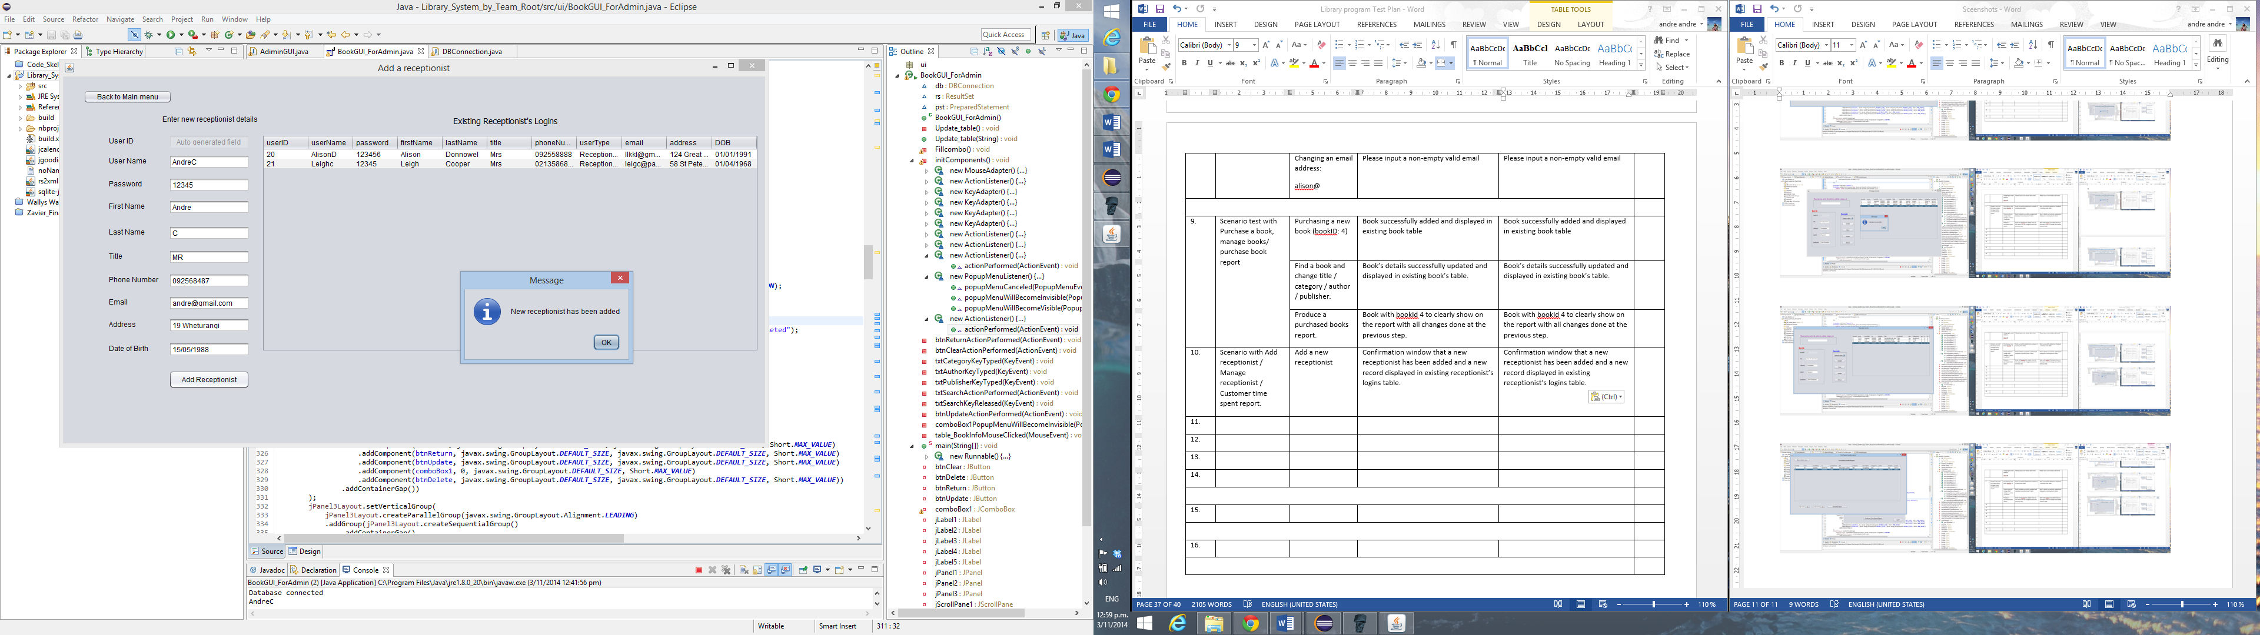

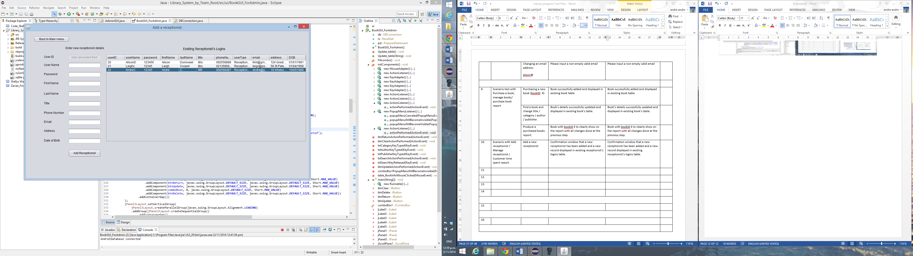

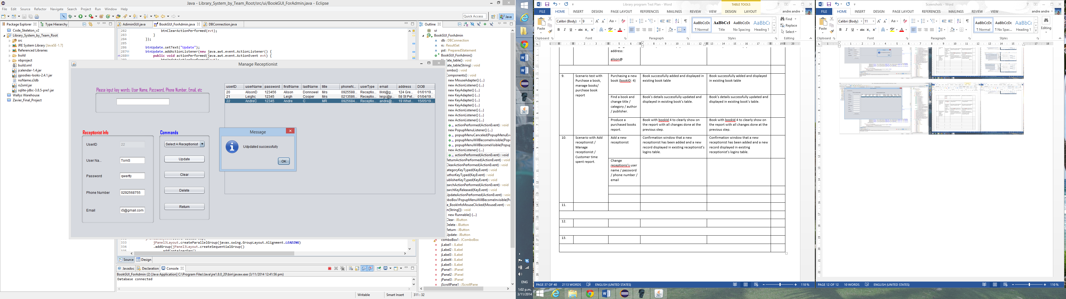

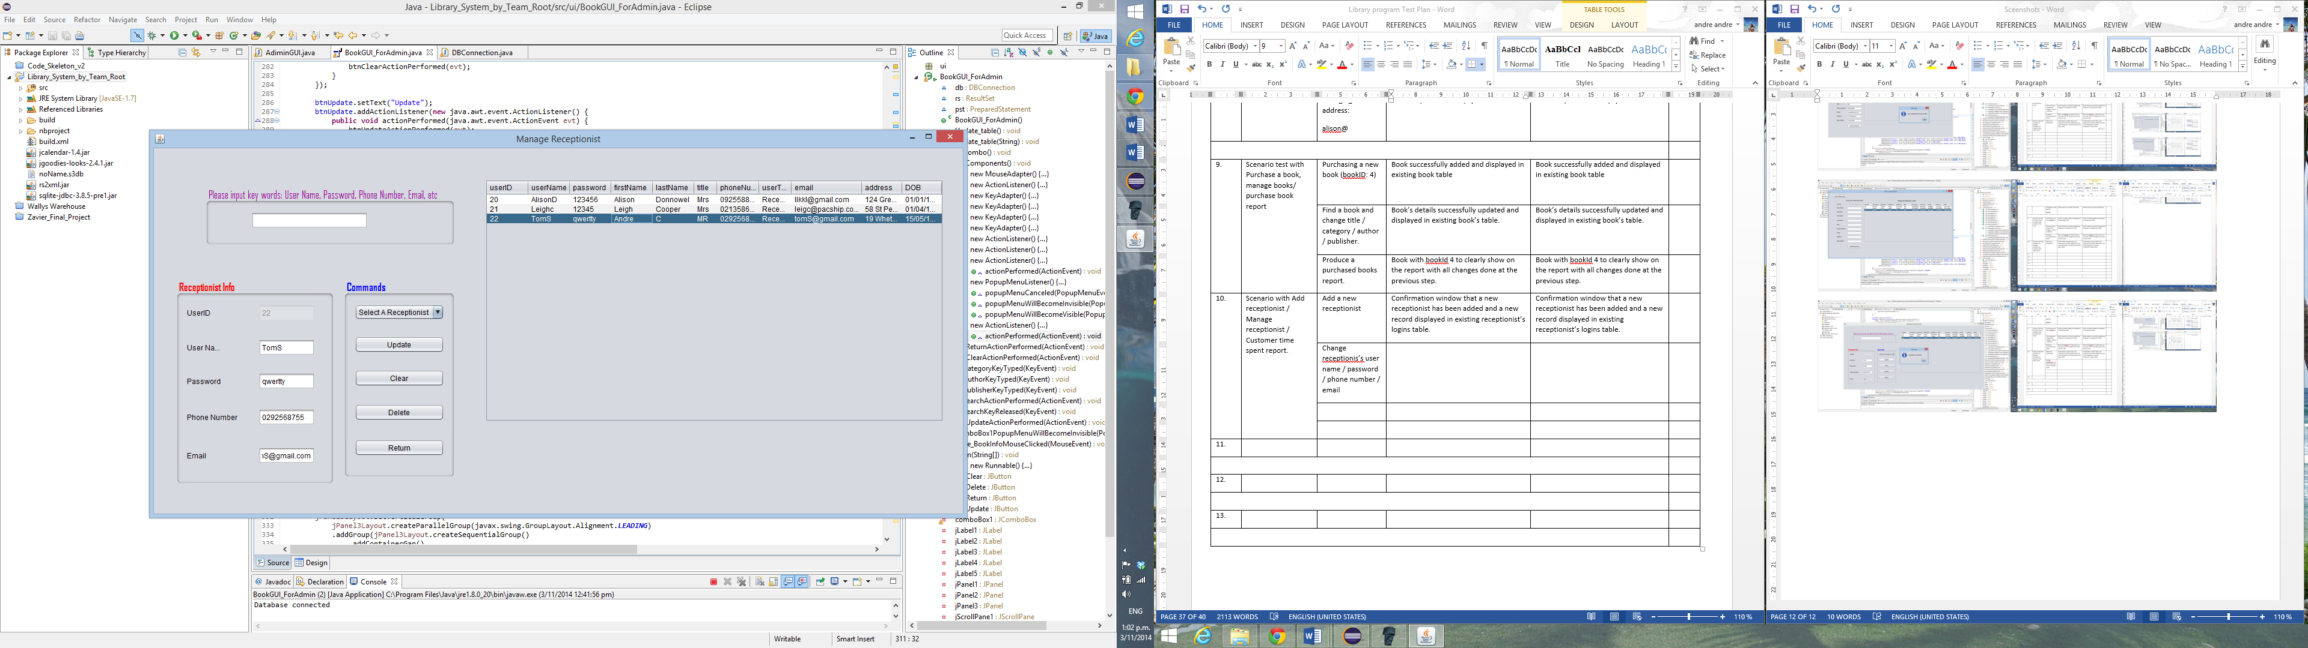

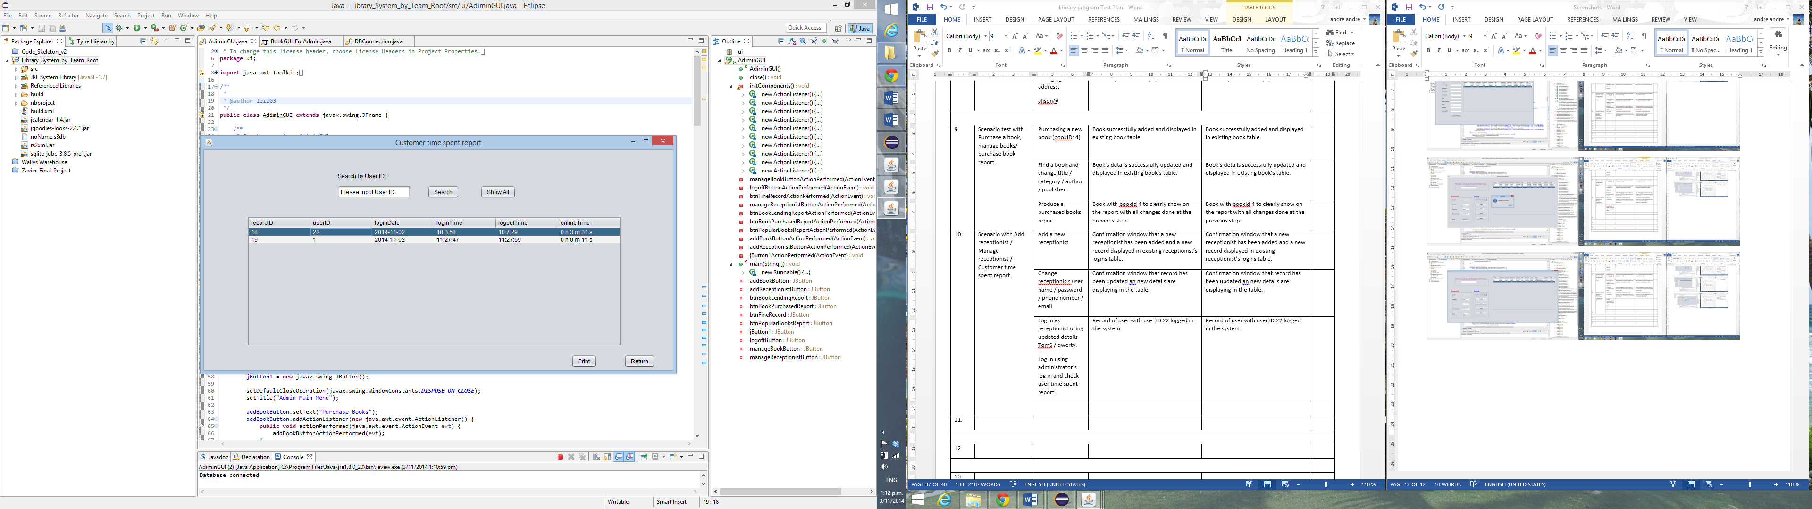

11)

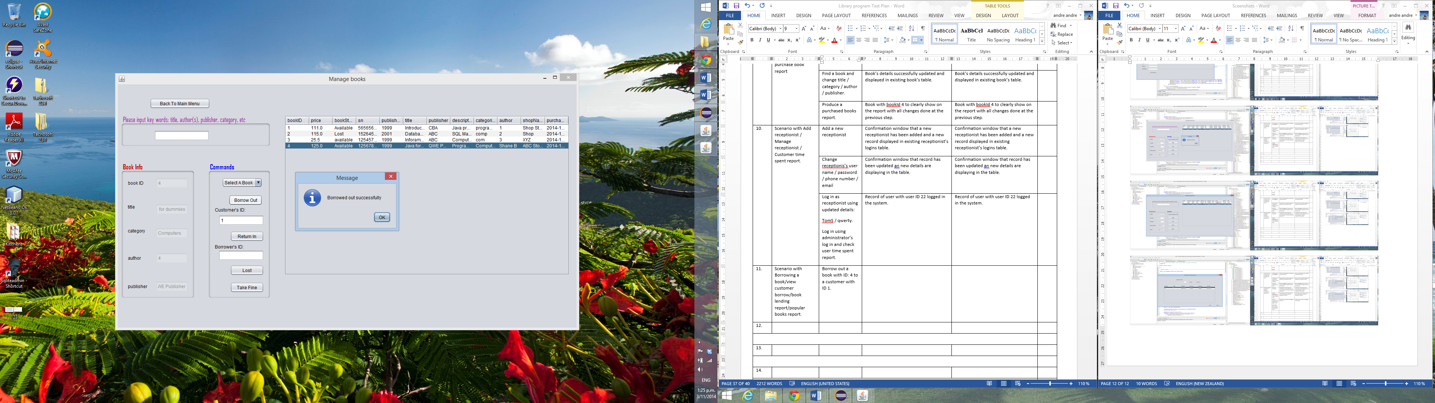

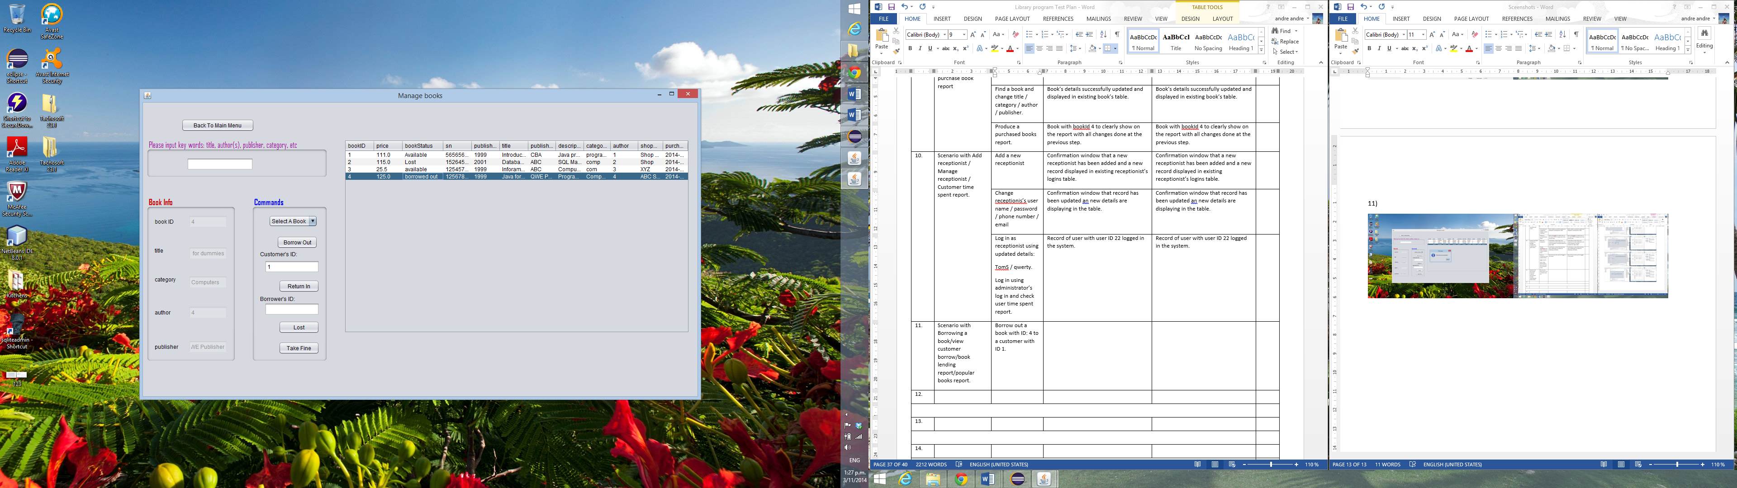

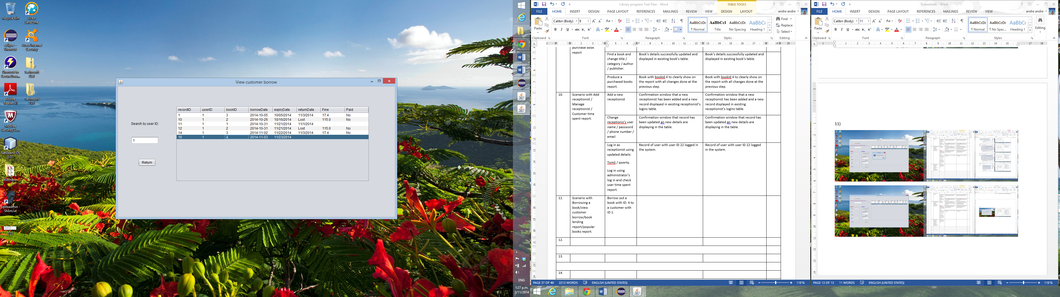

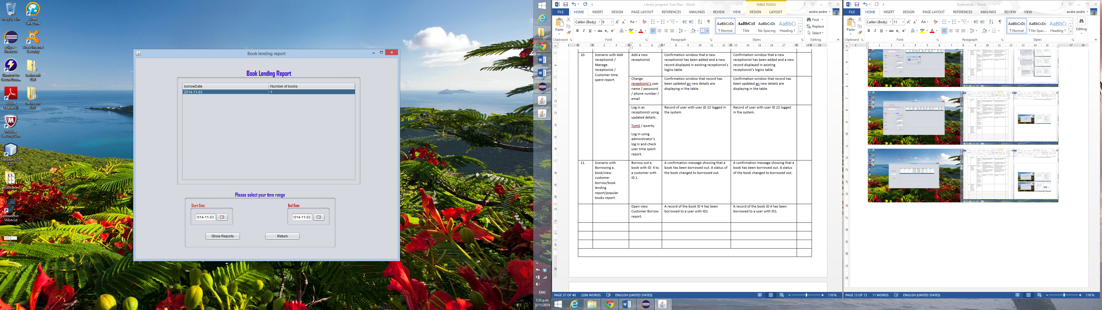

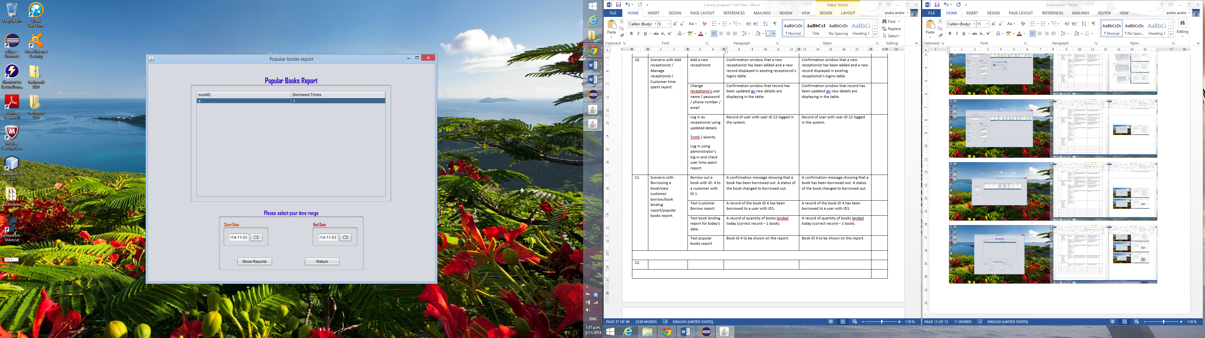

# Meeting minutes/discussion

Everybody’s assignment can be found in Workflow Class Diagram.vsd(pdf) on dropbox. Everybody’s jobs are highlighted in different colours. We should focus on basic functions of our project which are not bold and italic. Those jobs with bold and italic formats are problems that we could try to figure out if we finish our own parts of coding in advance, which will definitely give us good marks. Those jobs with black colours are difficult ones we may not to cover them considering that we only have two weeks left before the deadline. Keep in touch if you do not know what to do or how to do your jobs.

1. Baseline: *Assignment Code Skeleton* Eclipse Project on dropbox  
   including database and GUI. **Originally copy of project, do not modify it.** We could import it into our Eclipse or Netbean IDEs. **And we finish our own jobs on our own copy of project. Next Friday**, we may combine each one’s final project together.
2. Code Examples:
   1. *Wallys Warehouse* Eclipse Project on dropbox
   2. LoginGUI.java (form) and BorrowGUI.java(form) which show how to link one form to another form. (Tips: copy and paste to your project ass.ui package, right click🡪open with🡪window builder, you can show GUIs)
3. The initial step is to achieve all the basic functions based on assignment specifications. We may need more forms to certain functions ( Netbeans recommended🡪see Notes) . In our first step, we do not worry about form input validation, we will add more validation statements when we are completing our test cases. I hope we can finish our own work **before** **next Friday**. If we encounter any problems, we could have discussions any time through mails, phone calls, or text.
4. **Next Friday**, we may combine our works together and make our whole program compiled on Lab’s computer environment.
5. The week after next Friday, I suggest that we could finish our own parts of testing plan(like what we did in practical test 2) and add more validation statements to our own parts of programming before **Oct 24th(Friday)**.
6. **On Oct 24th(Friday)**, we may we may combine our works with new validation statements together and make our whole program compiled on Lab’s computer environment. And we should compile our test cases together to make it a final testing report.
7. Finally, happy coding everyone!

Notes:

NetBeans is pretty good for GUI design in case of more forms needed. And it can use Eclipse Project directly instead of importing to NetBeans IDE. So basically we can code in NetBeans IDE, and compile and run our codes in Eclipse IDE successfully. And there are some tricks to make make this happen, and even make our coding faster. If you would like to know, I can share with you guys.